RAJALAKSHMI ENGINEERING COLLEGE
RAJALAKSHMI NAGAR, THANDALAM – 602 105


GE23231

programingusing python

Laboratory Observation Note Book

NAME: MANOJ NJ

YEAR/BRANCH/SECTION: Ist YEAR /BIOTECHNOLOGY/B

REGISTER NO:230401090

SEMESTER: II

ACADEMIC YEAR: 2023 - 2024

S.  No. | Date | Title | Page  No. | Teacher’s Signature /  Remarks
Introduction to python-Variables-Datatypes-Input/Output-Formatting
1.1 | 9.3.24 | Converting Input Strings | 09
1.2 | 9.3.24 | Gross salary | 11
1.3 | 9.3.24 | Square Root | 13
1.4 | 9.3.24 | Gain percent | 15
1.5 | 9.3.24 | Deposits | 17
1.6 | 9.3.24 | Carpenter | 19
Operators in Python
2.1 | 16.3.24 | Widgets and Gizmos | 23
2.2 | 16.3.24 | Doll Sings | 25
2.3 | 16.3.24 | Birthday party | 27
2.4 | 16.3.24 | Hamming Weight | 29
2.5 | 16.3.24 | Compound Interest | 31
2.6 | 17.3.24 | Eligible to donate blood | 33
2.7 | 17.3.24 | C or D | 35
2.8 | 17.3.24 | Troy Battle | 37
2.9 | 17.3.24 | Tax and Tip | 39
2.10 | 17.3.24 | Return last digit of the given number | 41
Selection Structures in Python
3.1 | 21.3.24 | Admission eligibility | 45
3.2 | 21.3.24 | Classifying triangles | 47
3.3 | 21.3.24 | Electricity Bill | 49
3.4 | 21.3.24 | IN/OUT | 51
3.5 | 21.3.24 | Vowel or Constant | 53
3.6 | 21.3.24 | Leap Year | 55
3.7 | 21.3.24 | Month name to Days | 57
3.8 | 21.3.24 | Pythagorean triple | 59
3.9 | 21.3.24 | Second Last Digit | 61
3.10 | 21.3.24 | Chinese Zodiac | 63
Algorithmic Approach: Iteration Control Structures
4.1 | 28.3.24 | Factors of a Number | 69
4.2 | 28.3.24 | Non-Repeated Digits Count | 71
4.3 | 28.3.24 | Prime Checking | 73
4.4 | 28.3.24 | Next Perfect Square | 75
4.5 | 28.3.24 | Nth Fibonacci | 77
4.6 | 28.3.24 | Disarium Number | 79
4.7 | 28.3.24 | Sum of Series | 81
4.8 | 28.3.24 | Unique Digits Count | 83
4.9 | 28.3.24 | Product of single digits | 85
4.10 | 28.3.24 | Perfect Square After adding One | 87
Strings in Python
5.1 | 2.4.24 | Count chars | 113
5.2 | 2.4.24 | Decompress the String | 115
5.3 | 2.4.24 | First N Common Characters | 117
5.4 | 2.4.24 | Remove Characters | 119
5.5 | 3.4.24 | Remove Palindrome Words | 121
5.6 | 3.4.24 | Return Second Word in Uppercase | 123
5.7 | 3.4.24 | Reverse String | 125
5.8 | 3.4.24 | String characters balance Test | 127
5.9 | 3.4.24 | Unique Names | 129
5.10 | 3.4.24 | Username Domain Extension | 131
List in Python
6.1 | 30.4.24 | Monotonic array | 91
6.2 | 30.4.24 | Check pair with difference k . | 93
6.3 | 30.4.24 | Count Elements | 95
6.4 | 30.4.24 | Distinct Elements in an Array | 97
6.5 | 30.4.24 | Element Insertion | 99
6.6 | 30.4.24 | Find the Factor | 101
6.7 | 30.4.24 | Merge list | 103
6.8 | 30.4.24 | Merge Two Sorted Arrays Without Duplication | 105
6.9 | 30.5.24 | Print Element Location | 107
6.10 | 30.5.24 | Strictly increasing | 109
Tuples & Set
7.1 | 23.5.24 | Binary String | 151
7.2 | 1.6.24 | Check Pair | 153
7.3 | 1.6.24 | DNA Sequence | 155
7.4 | 1.6.24 | Print repeated no | 157
7.5 | 1.6.24 | Remove repeated | 159
7.6 | 1.6.24 | malfunctioning keyboard | 161
7.7 | 1.6.24 | American keyboard | 163
Dictionary
8.1 | 13.6.24 | Uncommon Words | 167
8.2 | 13.6.24 | Sort Dictionary By Values Summation | 169
8.3 | 13.6.24 | Winner Of Election | 171
8.4 | 13.6.24 | Student Record | 173
8.5 | 13.6.24 | Scramble Score | 175
Functions
9.1 | 15.6.24 | Abundant Number | 135
9.2 | 15.6.24 | Automorphic number or not | 137
9.3 | 15.6.24 | Check Product of Digits | 139
9.4 | 15.6.24 | Christmas Discount | 141
9.5 | 15.6.24 | Coin Change | 143
9.6 | 15.6.24 | Difference Sum | 145
9.7 | 15.6.24 | Ugly number | 147
Searching & Sorting
10.1 | 16.6.24 | Merge Sort | 179
10.2 | 16.6.24 | Bubble Sort | 181
10.3 | 16.6.24 | Peak Element | 183
10.4 | 16.6.24 | Binary Search | 185
10.5 | 16.6.24 | Frequency of Numbers | 187

01 - Introduction to Python-Variables-Datatypes
Input/Output-Formatting

Ex. No. : 1.1 Date: 9.3.24
Register No.: 230401090 Name: MANOJ NJ

Converting Input Strings
Write a program to convert strings to an integer and float and display its type.
Sample Output:
10,<class 'int'>
10.9,<class 'float'>

For example:
Input | Result
10  10.9 | 10,<class 'int'>  10.9,<class 'float'>

a=input()
b=input()
c=int(a)
d=float(b)
print(c,type(c),sep=",")
print("{:0.1f}".format(d),type(d),sep=",")

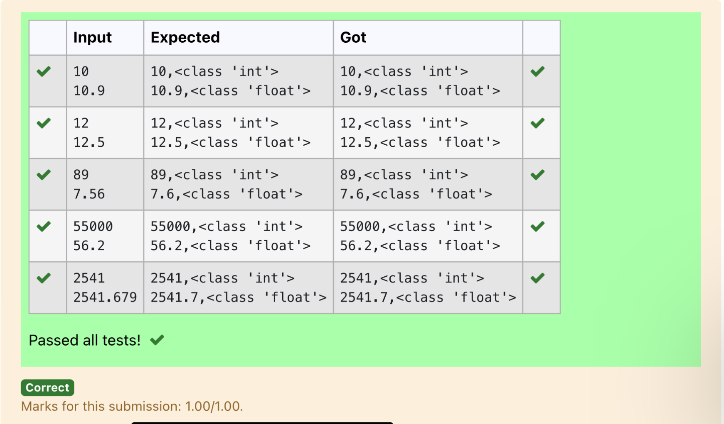

Ex. No. : 1.2 Date: 9.3.24
Register No.: 230401090 Name: MANOJ NJ

Gross Salary
Ramesh’s basic salary is input through the keyboard. His dearness allowance is 40% of his basic salary, and his house rent allowance is 20% of his basic salary. Write a program to calculate his gross salary.

Sample Input:
10000
Sample Output:
16000
For example:
Input | Result
10000 | 16000

s=int(input())
da=s*0.4
ha=s*0.2
print(int(s+da+ha))

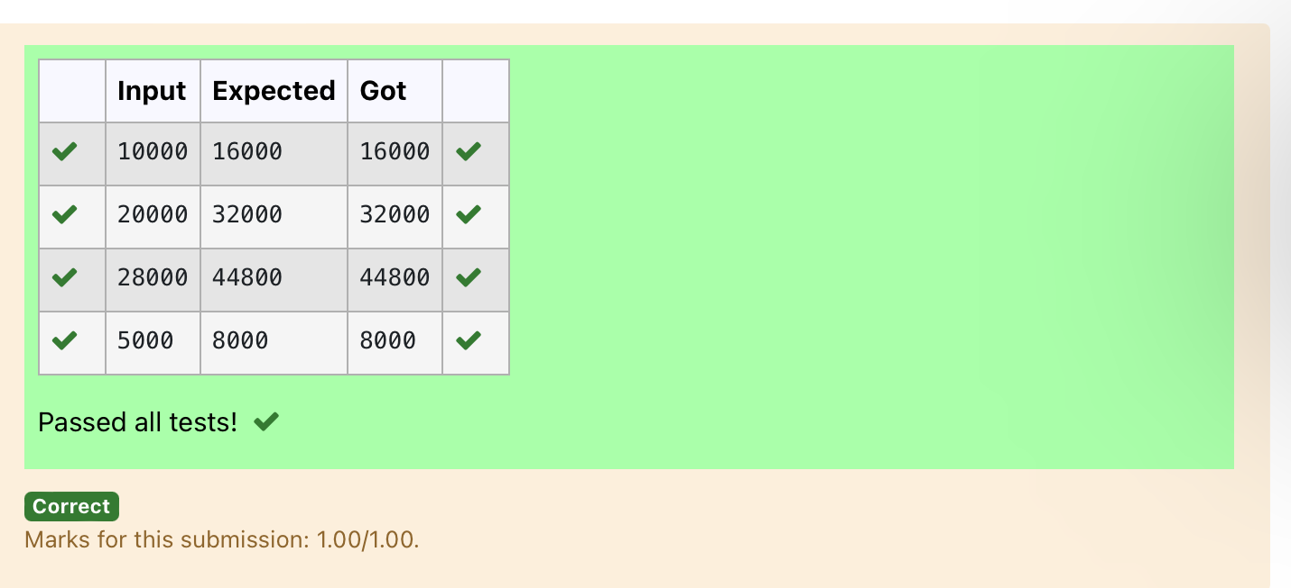

Ex. No. : 1.3 Date: 9.3.2024
Register No.: 230401090 Name: MANOJ NJ

Square Root
Write a simple python program to find the square root of a given floating point number. The output should be displayed with 3 decimal places.

Sample Input:
8.00
Sample Output:
2.828
For example:
Input | Result
14.00 | 3.742

import math
a=float(input())
s=math.sqrt(a)
print("{:.3f}".format(s))

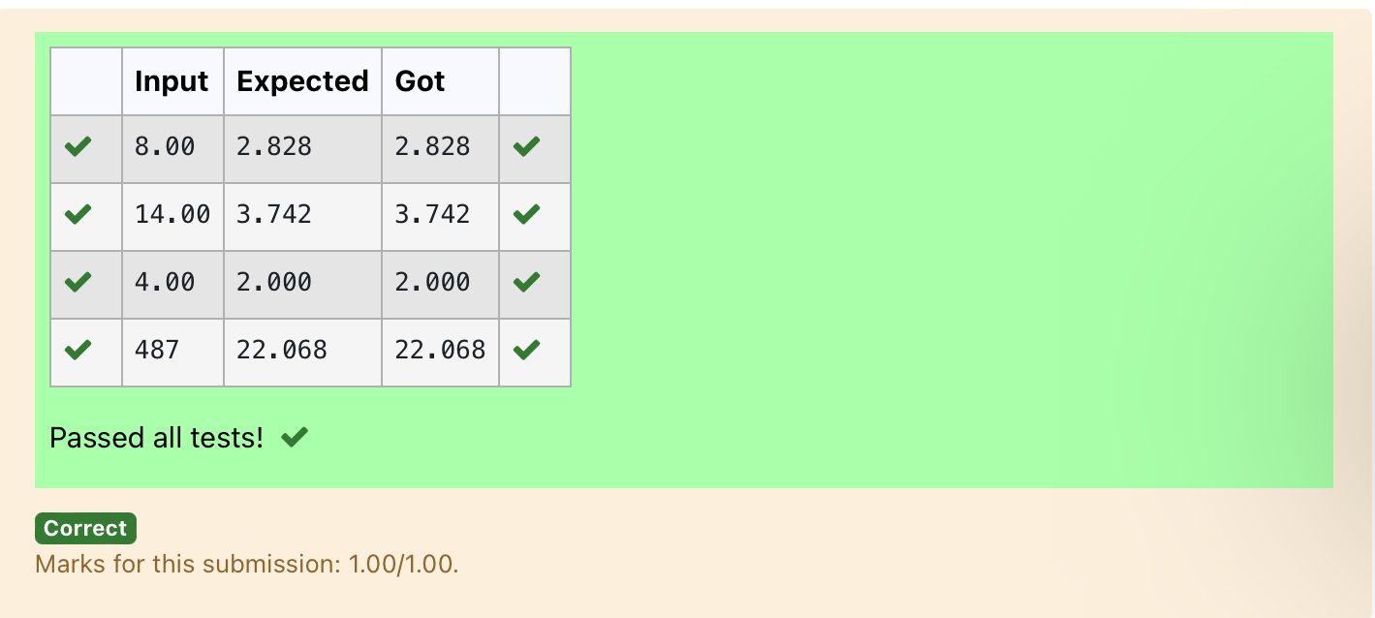

Ex. No. : 1.4 Date: 9.3.2024
Register No.: 230401090 Name: MANOJ NJ

Gain percent
Alfred buys an old scooter for Rs. X and spends Rs. Y on its repairs. If he sells the scooter for Rs. Z (Z>X+Y). Write a program to help Alfred to find his gain percent. Get all the above-mentioned values through the keyboard and find the gain percent.

Input Format:
The first line contains the Rs X
The second line contains Rs Y
The third line contains Rs Z
Sample Input:
10000
250
15000
Sample Output:
46.34 is the gain percent.

For example:
Input | Result
45500  500  60000 | 30.43 is the gain percent.

buys=int(input())
repair=int(input())
sells=int(input())
g=(((sells-(buys+repair))/(buys+repair))*100)
print("{:.2f}".format(g), "is the gain percent.")

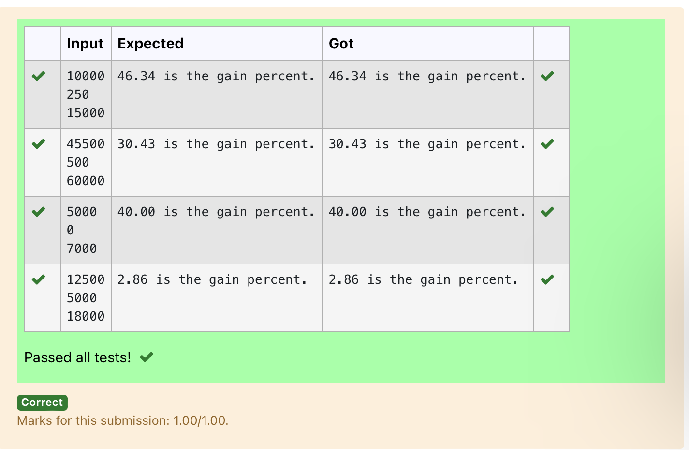

Ex. No. : 1.5 Date: 9.3.2024
Register No.: 230401090 Name: MANOJ NJ

Deposits
In many jurisdictions, a small deposit is added to drink containers to encourage people to recycle them. In one particular jurisdiction, drink containers holding one liter or less have a $0.10 deposit and drink containers holding more than one liter have a $0.25 deposit. Write a program that reads the number of containers of each size(less and more) from the user. Your program should continue by computing and displaying the refund that will be received for returning those containers. Format the output so that it includes a dollar sign and always displays exactly two decimal places.
Sample Input
10
20
Sample Output
Your total refund will be $6.00.
For example:
Input | Result
20  20 | Your total refund will be $7.00.

a=int(input())
b=int(input())
c=a*0.1
d=b*0.25
e=c+d
print("Your total refund will be ${:.2f}.".format(e))

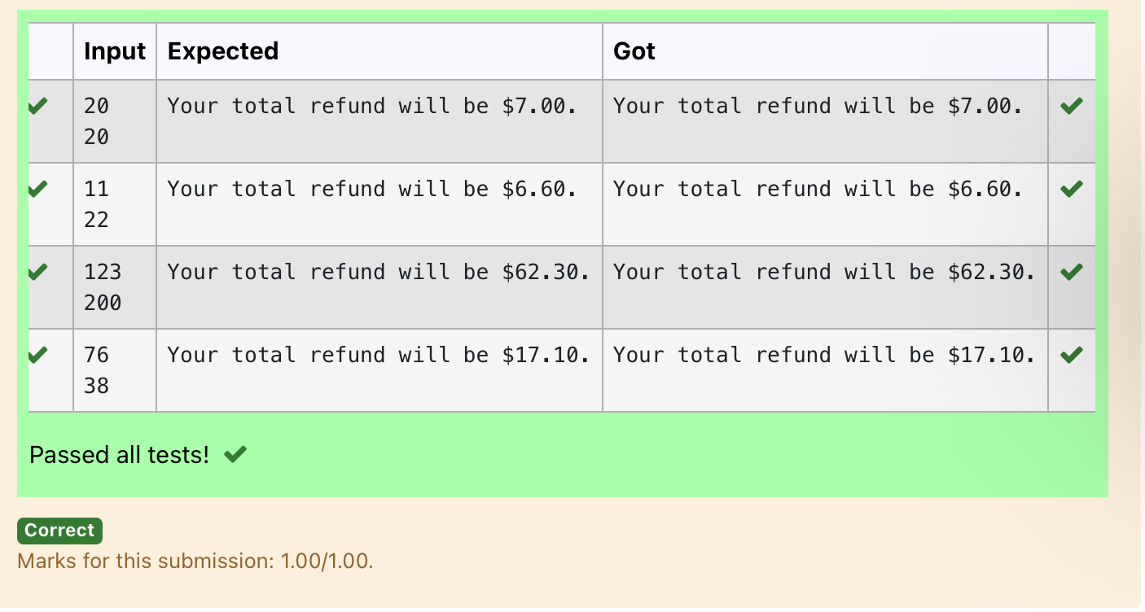

Ex. No. : 1.6 Date: 9.3.2024
Register No.: 230401090 Name: MANOJ NJ

Carpenter
Justin is a carpenter who works on an hourly basis. He works in a company where he is paid Rs 50 for an hour on weekdays and Rs 80 for an hour on weekends. He works 10 hrs more on weekdays than weekends. If the salary paid for him is given, write a program to find the number of hours he has worked on weekdays and weekends.
Hint:
If the final result(hrs) are in -ve convert that to +ve using abs() function
The abs() function returns the absolute value of the given number.
number = -20
absolute_number = abs(number)
print(absolute_number)
# Output:20

Sample Input:
450
Sample Output:
weekdays 10.38
weekend 0.38
For example:
Input | Result
450 | weekdays 10.38  weekend 0.38

s=int(input())
a=(500-s)/130
print("weekdays {:.2f}".format(abs(a)+10))
print("weekend {:.2f}".format(abs(a)))

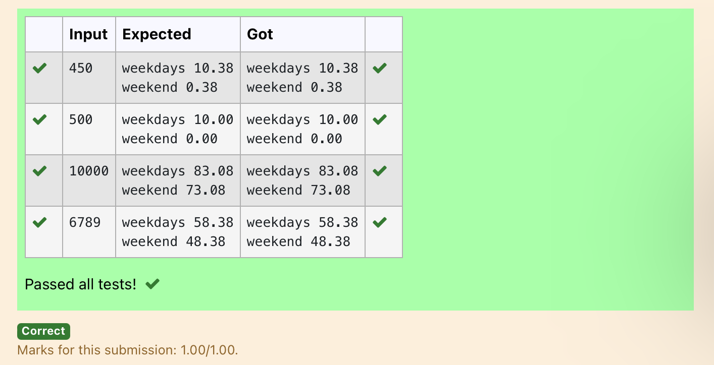

02- Operators in Python

Ex. No. : 2.1 Date: 16.3.2024
Register No.: 230401090 Name: MANOJ NJ

Widgets and Gizmos
An online retailer sells two products: widgets and gizmos. Each widget weighs 75 grams. Each gizmo weighs 112 grams. Write a program that reads the number of widgets and the number of gizmos from the user. Then your program should compute and display the total weight of the parts.

Sample Input
10
20
Sample Output
The total weight of all these widgets and gizmos is 2990 grams.
For example:
Input | Result
10  20 | The total weight of all these widgets and gizmos is 2990 grams.
a=int(input())
b=int(input())
print("The total weight of all these widgets and gizmos is",((a*75)+(b*112)),"grams.")

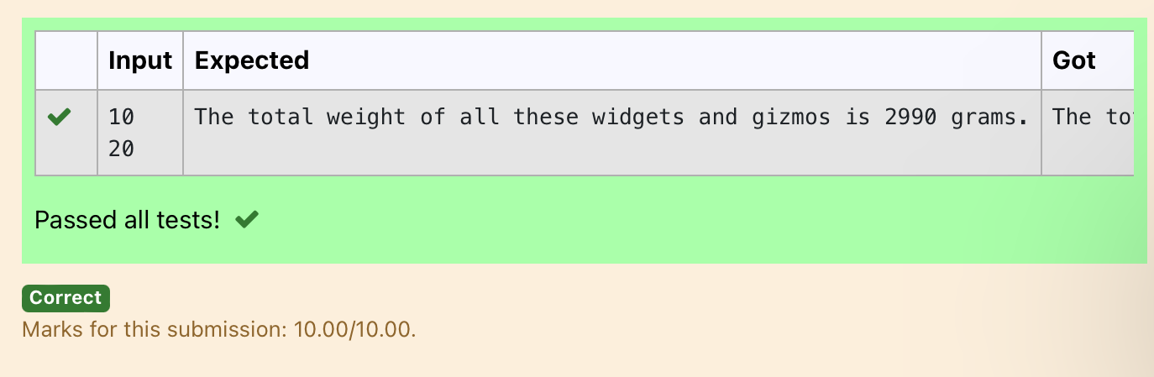

Ex. No. : 2.2 Date: 16.03.2024
Register No.: 230401090 Name: MANOJ NJ

Doll Sings
In London, every year during Dasara there will be a very grand doll show. People try to invent new dolls of different varieties. The best-sold doll's creator will be awarded with a cash prize. So people broke their heads to create dolls innovatively. Knowing this competition, Mr.Lokpaul tried to create a doll that sings only when an even number is pressed and the number should not be zero and greater than 100.
IF Lokpaul wins print true, otherwise false.

Sample Input
10
Sample Output
True
Explanation:
Since 10 is an even number and a number between 0 and 100, True is printed

a=int(input())
if(a>0 and a<100 and a%2==0):
print("True")
else:
print("False")

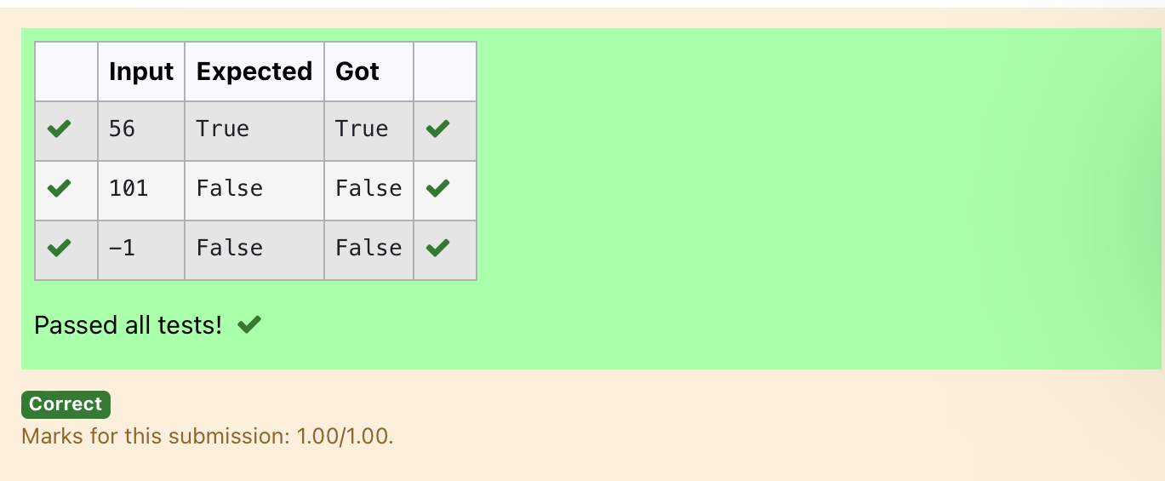

Ex. No. : 2.3 Date: 16.03.2024
Register No.: 230401090 Name: MANOJ NJ

Birthday Party
Mr. X's birthday is in next month. This time he is planning to invite N of his friends. He wants to distribute some chocolates to all of his friends after the party. He went to a shop to buy a packet of chocolates. At the chocolate shop, 4 packets are there with different numbers of chocolates. He wants to buy such a packet which contains a number of chocolates, which can be distributed equally among all of his friends. Help Mr. X to buy such a packet.

Input Given:
N-No of friends
P1,P2,P3 AND P4-No of chocolates
OUTPUT:
"True" if he can buy that packet and "False" if he can't buy that packet.
SAMPLE INPUT AND OUTPUT:
5
25
12
10
9
OUTPUT
True False True False

a=int(input())
b=int(input())
c=int(input())
d=int(input())
e=int(input())
print(b%a==0,c%a==0,d%a==0,e%a==0)

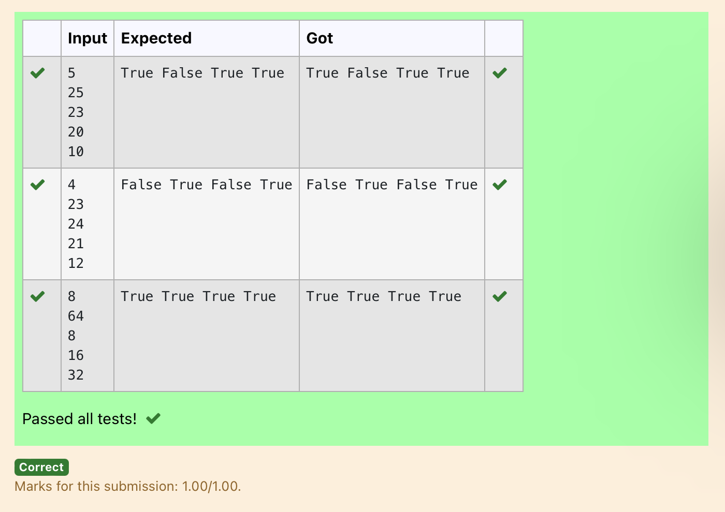

Ex. No. : 2.4 Date: 16.03.2024
Register No.: 230401090 Name: MANOJ NJ

Hamming Weight
Write a python program that takes a integer between 0 and 15 as input and displays the number of '1' s in its binary form.(Hint:use python bitwise operator.
Sample Input
3
Sample Output:
2
Explanation:
The binary representation of 3 is 011, hence there are 2 ones in it. so the output is 2.

a=int(input())
n=bin(a)
n=n.replace("0b","")
s=str(n)
c=list(s)
d=0
for i in range(len(c)):
if(int(c[i])==1):
d+=1
print(d)

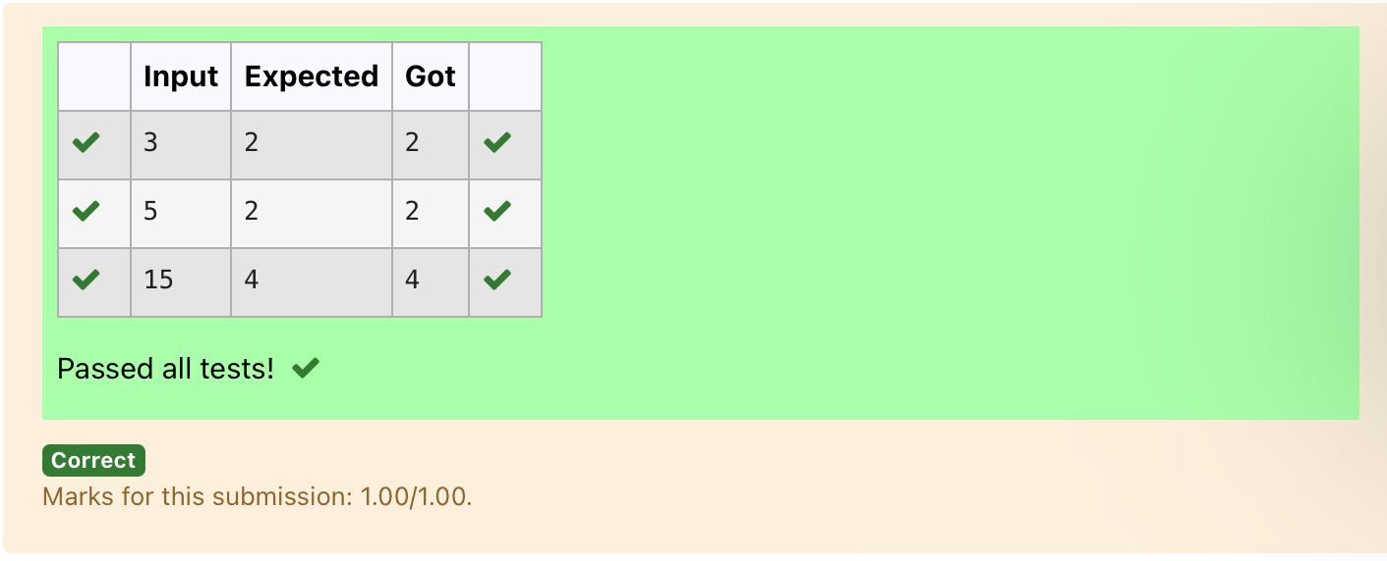

Ex. No. : 2.5 Date: 16.03.2024
Register No.: 230401090 Name: MANOJ NJ

Compound Interest
Pretend that you have just opened a new savings account that earns 4 percent interest per year. The interest that you earn is paid at the end of the year, and is added to the balance of the savings account. Write a program that begins by reading the amount of money deposited into the account from the user. Then your program should compute and display the amount in the savings account after 1, 2, and 3 years. Display each amount so that it is rounded to 2 decimal places.
Sample Input:
10000
Sample Output:
Balance as of end of Year 1: $10400.00.
Balance as of end of Year 2: $10816.00.
Balance as of end of Year 3: $11248.64

a=int(input())
b=(a*0.04)+a
c=b+(b*0.04)
d=c+(c*0.04)
print("Balance as of end of Year 1: ${:.2f}.".format(b))
print("Balance as of end of Year 2: ${:.2f}.".format(c))
print("Balance as of end of Year 3: ${:.2f}.".format(d))

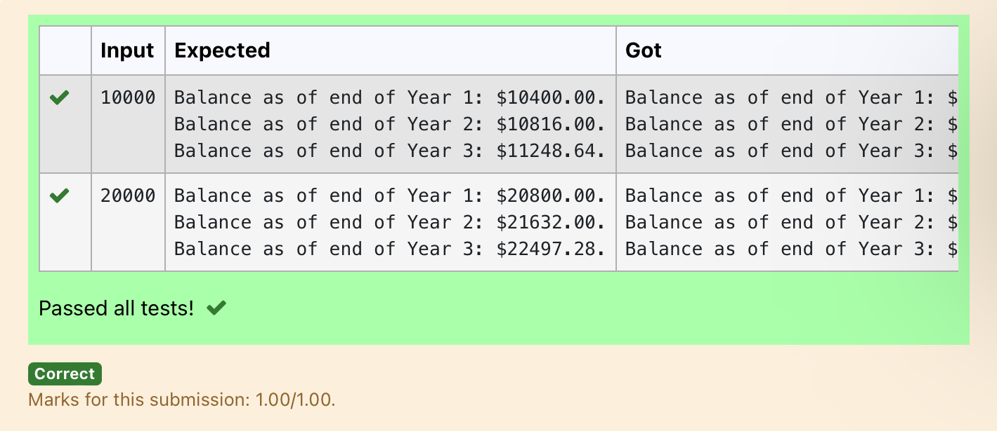

Ex. No. : 2.6 Date: 17.03.2024
Register No.: 230401090 Name: MANOJ NJ

Eligible to donate blood
A team from the Rotract club had planned to conduct a rally to create awareness among the Coimbatore people to donate blood. They conducted the rally successfully. Many of the Coimbatore people realized it and came forward to donate their blood to nearby blood banks. The eligibility criteria for donating blood are people should be above or equal to 18 and his/ her weight should be above 40. There was a huge crowd and staff in the blood bank found it difficult to manage the crowd. So they decided to keep a system and ask the people to enter their age and weight in the system. If a person is eligible he/she will be allowed inside.
Write a program and feed it to the system to find whether a person is eligible or not.

Input Format:
Input consists of two integers that correspond to the age and weight of a person respectively.
Output Format:
Display True(IF ELIGIBLE)
Display False (if not eligible)
Sample Input
19
45
Sample Output
True
a=int(input())
b=int(input())
if(a>=18 and b>40):
print("True")
else:
print("False")

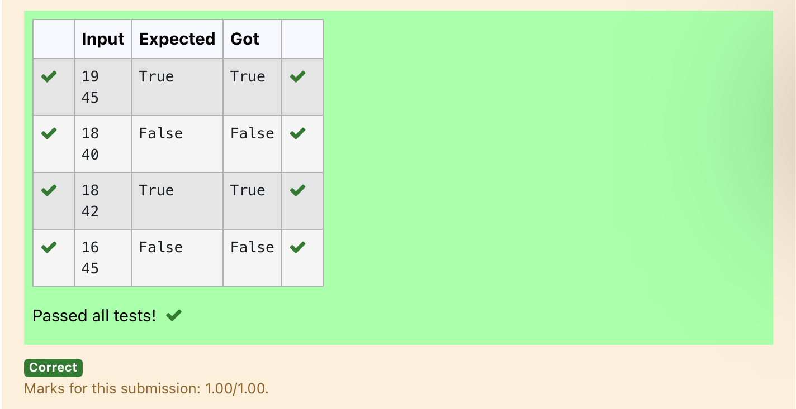

Ex. No. : 2.7 Date: 17.03.2024
Register No.: 230401090 Name: MANOJ NJ

C or D
Mr.Ram has been given a problem kindly help him to solve it. The input of the program is either 0 or 1. IF 0 is the input he should display "C" if 1 is the input it should display "D".There is a constraint that Mr. Ram should use either logical operators or arithmetic operators to solve the problem, not anything else.
Hint:
Use ASCII values of C and D.

Input Format:
An integer x, 0<=x<=1. .
Output Format:
output a single character "C" or "D"depending on the value of x.
Input 1:
0
Output 1:
C
Input 2:
1

Output 1:
D

a=int(input())
if(a==0):
print("C")
else:
print("D")

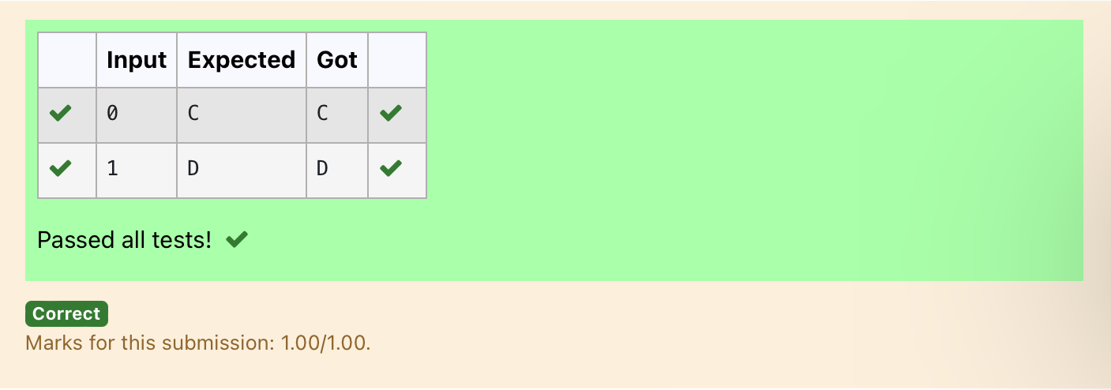

Ex. No. : 2.8 Date: 17.03.2024
Register No.: 230401090 Name: MANOJ NJ

Troy Battle
In the 1800s, the battle of Troy was led by Hercules. He was a superstitious person. He believed that his crew can win the battle only if the total count of the weapons in hand is in multiple of 3 and the soldiers are in an even number of count. Given the total number of weapons and the soldier's count, Find whether the battle can be won or not according to Hercules's belief. If the battle can be won print True otherwise print False.
Input format:
Line 1 has the total number of weapons
Line 2 has the total number of Soldiers.
Output Format:
If the battle can be won print True otherwise print False.
Sample Input:
32
43
Sample Output:'
False

a=int(input())
b=int(input())
if(a%3==0 and b%2==0):
print("True")
else:
print("False")

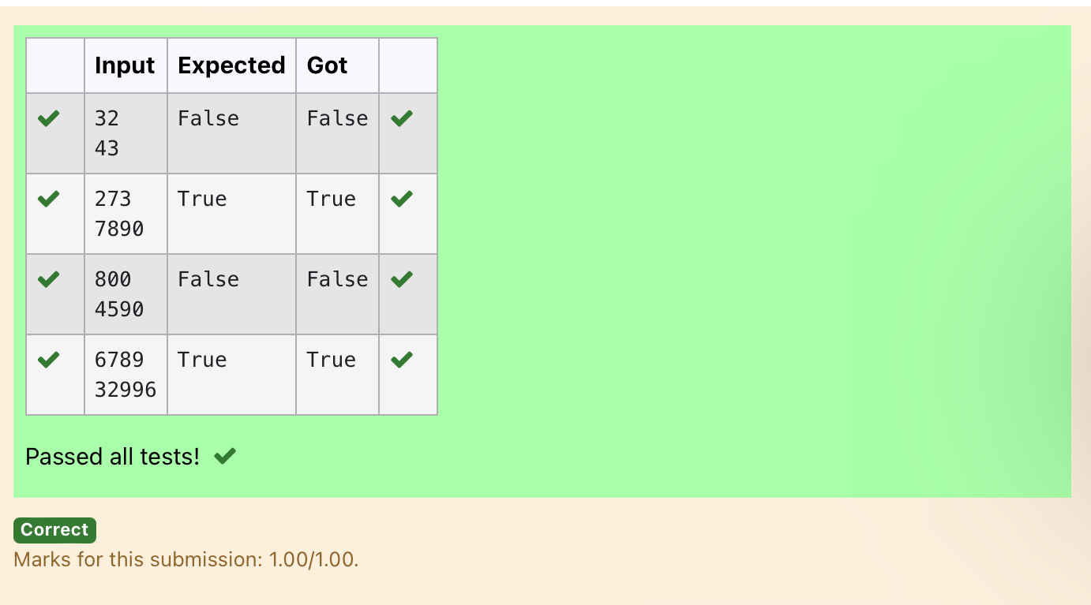

Ex. No. : 2.9 Date: 17.03.2024
Register No.: 230401090 Name: MANOJ NJ

Tax and Tip
The program that you create for this exercise will begin by reading the cost of a meal ordered at a restaurant from the user. Then your program will compute the tax and tip for the meal. Use your local tax rate (5 percent) when computing the amount of tax owing. Compute the tip as 18 percent of the meal amount (without the tax). The output from your program should include the tax amount, the tip amount, and the grand total for the meal including both the tax and the tip. Format the output so that all of the values are displayed using two decimal places.
Sample Input
100
Sample Output
The tax is 5.00 and the tip is 18.00, making the total 123.00

a=int(input())
print("The tax is {:.2f} and the tip is {:.2f}, making the total {:.2f}".format((a*0.05),(a*0.18),(a+((a*0.05)+(a*0.18)))))

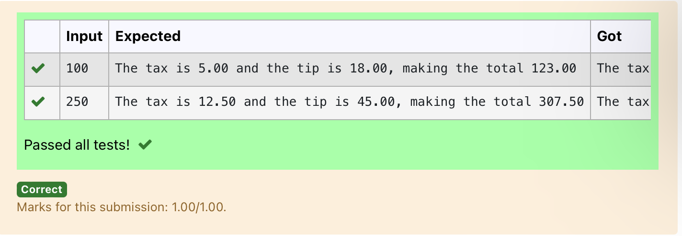
Ex. No. : 2.10 Date: 17.03.2024
Register No.: 230401090 Name: MANOJ NJ

Return last digit of the given number
Write a program that returns the last digit of the given number. Last digit is being referred to the least significant digit i.e. the digit in the ones (units) place in the given number.
The last digit should be returned as a positive number.
For example,
if the given number is 197, the last digit is 7
if the given number is -197, the last digit is 7
For example:
Input | Result
123 | 3

a=int(input())

print(abs(a)%10)

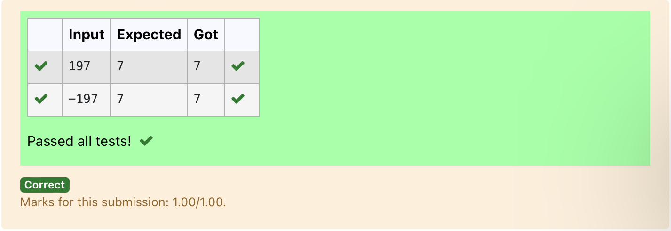

03 - Selection Structures in Python

Ex. No. : 3.1 Date: 21.03.2024
Register No.: 230401090 Name: MANOJ NJ

Admission Eligibility
Write a program to find the eligibility of admission for a professional course based on the following criteria:
Marks in Maths >= 65
Marks in Physics >= 55
Marks in Chemistry >= 50
Or
Total in all three subjects >= 180
Sample Test Cases
Test Case 1
Input
70
60
80
Output
The candidate is eligible
Test Case 2
Input
50
80
80
Output
The candidate is eligible
Test Case 3
Input
50
60
40
Output
The candidate is not eligible
For example:
Input | Result
50  80  80 | The candidate is eligible

a=int(input())
b=int(input())
c=int(input())
if(a>=65 and b>=55 and c>=50):
print("The candidate is eligible")
elif(a+b+c>=180):
print("The candidate is eligible")
else:
print("The candidate is not eligible")

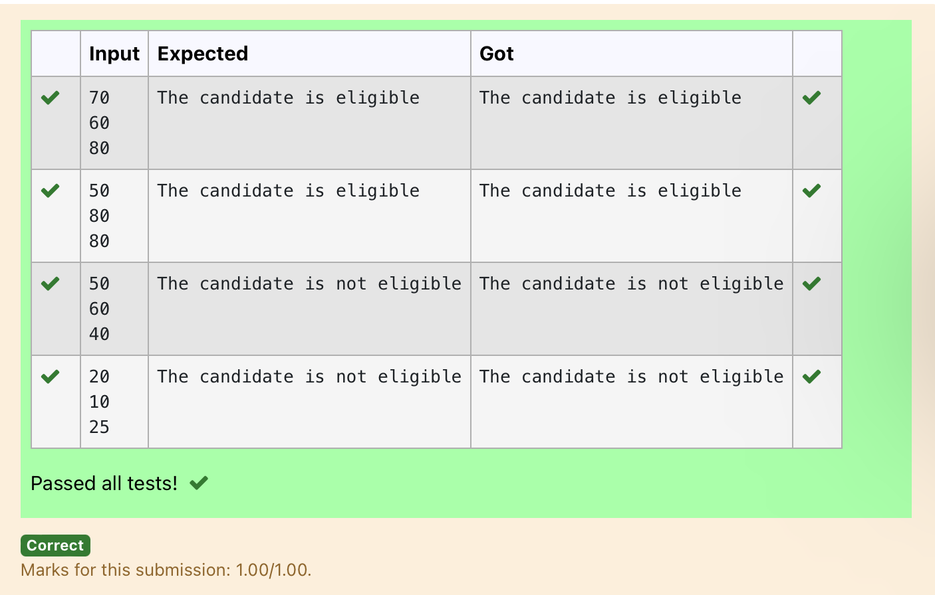

Ex. No. : 3.2 Date: 21.03.2024
Register No.: 230401090 Name: MANOJ NJ

Classifying Triangles
A triangle can be classified based on the lengths of its sides as equilateral, isosceles or scalene. All three sides of an equilateral triangle have the same length. An isosceles triangle has two sides that are the same length, and a third side that is a different length. If all of the sides have different lengths then the triangle is scalene.
Write a program that reads the lengths of the three sides of a triangle from the user. Then display a message that states the triangle’s type.
Sample Input 1
60
60
60
Sample Output 1
That's a equilateral triangle

For example:
Input | Result
40  40  80 | That's a isosceles triangle
a=int(input())
b=int(input())
c=int(input())
if(a==b and b==c):
print("That's a equilateral triangle")
elif(a!=b and b==c or a==b and b!=c):
print("That's a isosceles triangle")
elif(a!=b and b!=c):
print("That's a scalene triangle")

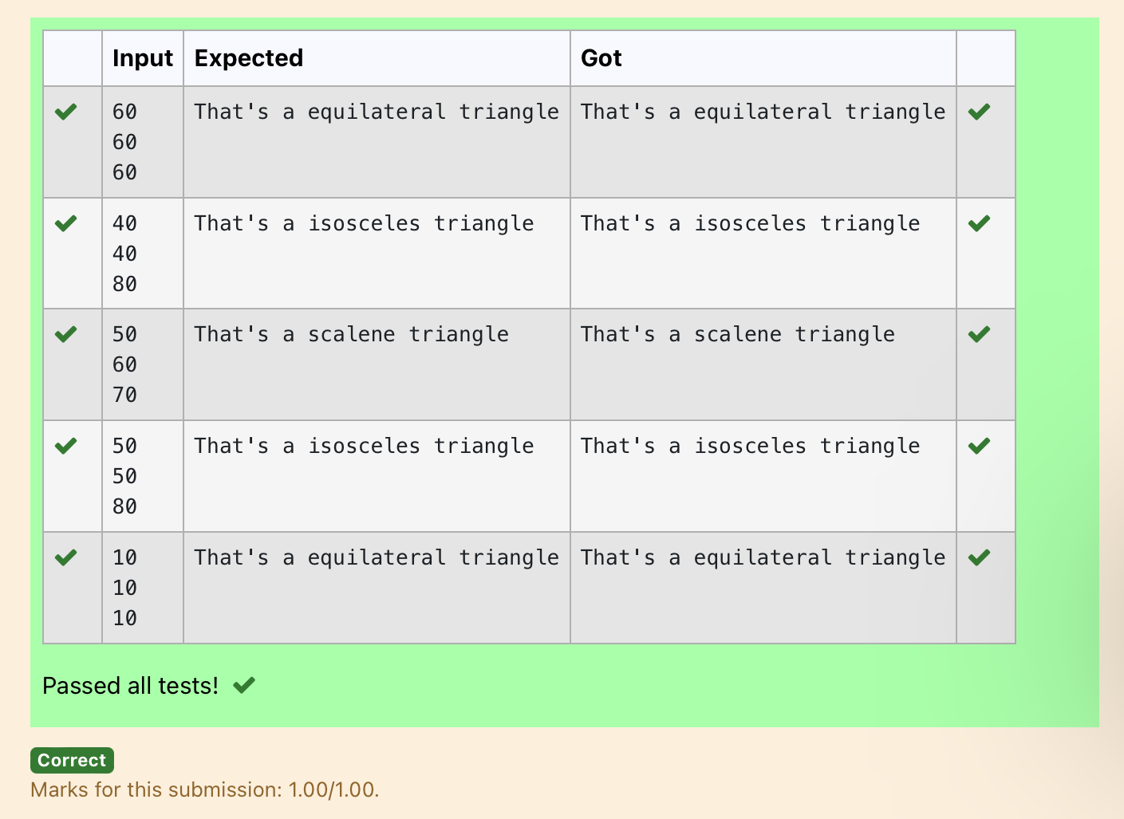

Ex. No. : 3.3 Date: 21.03.2024
Register No.: 230401090 Name: MANOJ NJ

Electricity Bill
Write a program to calculate and print the Electricity bill where the unit consumed by the user is given from test case. It prints the total amount the customer has to pay. The charge are as follows:
Unit Charge / Unit
Upto 199 @1.20
200 and above but less than 400 @1.50
400 and above but less than 600 @1.80
600 and above @2.00
If bill exceeds Rs.400 then a surcharge of 15% will be charged and the minimum bill should be of Rs.100/-
Sample Test Cases
Test Case 1
Input
50
Output
100.00
Test Case 2
Input
300
Output
517.50

For example:
Input | Result
500 | 1035.00

a=float(input())
b=0
if(a<=199):
b=a*1.2
elif(200<=a<400):
b=a*1.5
elif(400<=a<600):
b=a*1.8
elif(a>600):
b=a*2.0
if (int(b)<100):
print("{:.2f}".format(100))
else:
if(b>400.00):
print("{:.2f}".format((b+(b*0.15))))
else:
print("{:.2f}".format(b))

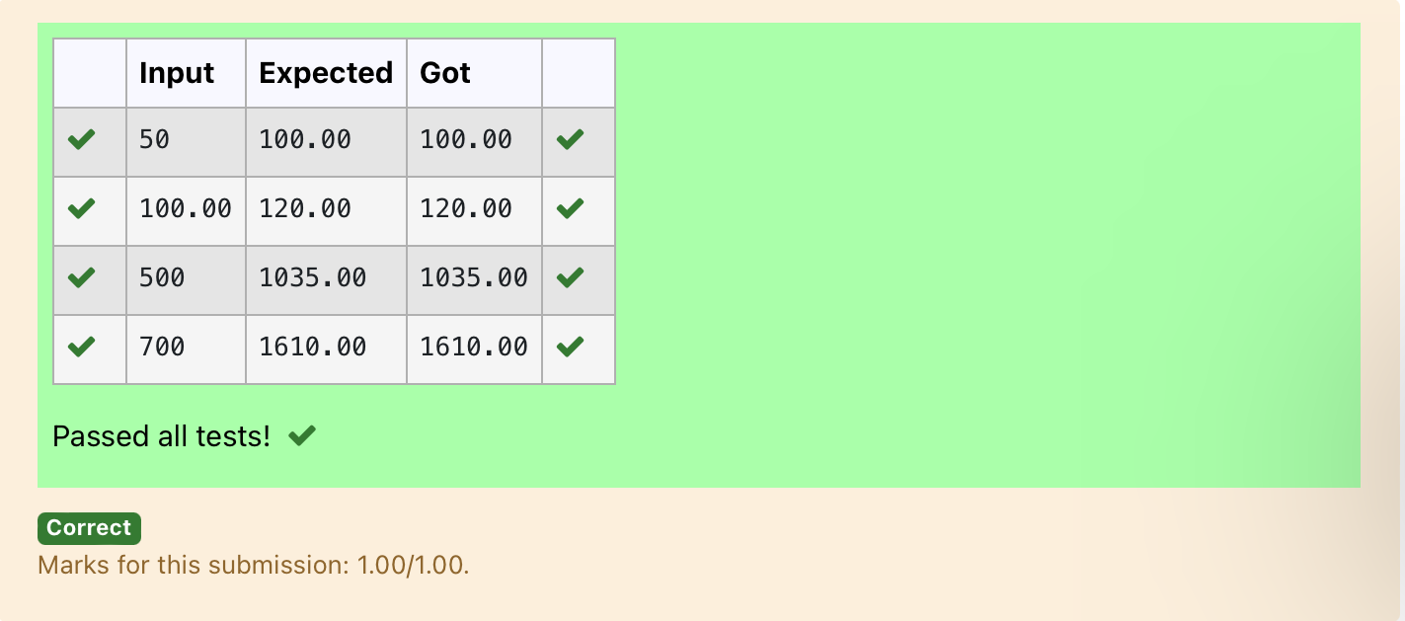

Ex. No. : 3.4 Date: 21.03.2024
Register No.: 230401090 Name: MANOJ NJ

IN/OUT
Ms. Sita, the faculty handling programming lab for you is very strict. Your seniors have told you that she will not allow you to enter the week's lab if you have not completed atleast half the number of problems given last week. Many of you didn't understand this statement and so they requested the good programmers from your batch to write a program to find whether a student will be allowed into a week's lab given the number of problems given last week and the number of problems solved by the student in that week.

Input Format:
Input consists of 2 integers.
The first integer corresponds to the number of problems given and the second integer corresponds to the number of problems solved.
Output Format:
Output consists of the string “IN” or “OUT”.
Sample Input and Output:
Input
8
3
Output
OUT
For example:
Input | Result
8  3 | OUT

a=int(input())
b=int(input())
c=(a/2)
if(c>b):
print("OUT")
else:
print("IN")

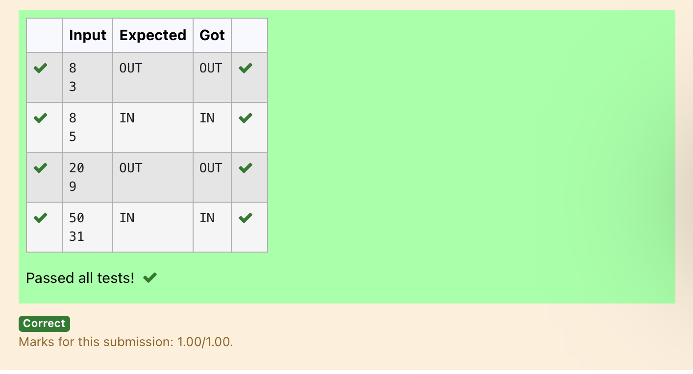

Ex. No. : 3.5 Date: 21.03.2024
Register No.: 230401090 Name: MANOJ NJ

Vowel or Consonant
In this exercise you will create a program that reads a letter of the alphabet from the user. If the user enters a, e, i, o or u then your program should display a message indicating that the entered letter is a vowel. If the user enters 'y' then your program should display a message indicating that sometimes y is a vowel, and sometimes y is a consonant. Otherwise your program should display a message indicating that the letter is a consonant.
Sample Input 1
i
Sample Output 1
It's a vowel.
Sample Input 2
y
Sample Output 2
Sometimes it's a vowel... Sometimes it's a consonant.
Sample Input3
c
Sample Output 3
It's a consonant.

For example:
Input | Result
y | Sometimes it's a vowel... Sometimes it's a consonant.
u | It's a vowel.
p | It's a consonant.

a=input()
if(a=='a' or a=='e' or a=='i' or a=='o' or a=='u'):
print("It's a vowel.")
elif(a=='y'):
print("Sometimes it's a vowel... Sometimes it's a consonant.")
else:
print("It's a consonant.")
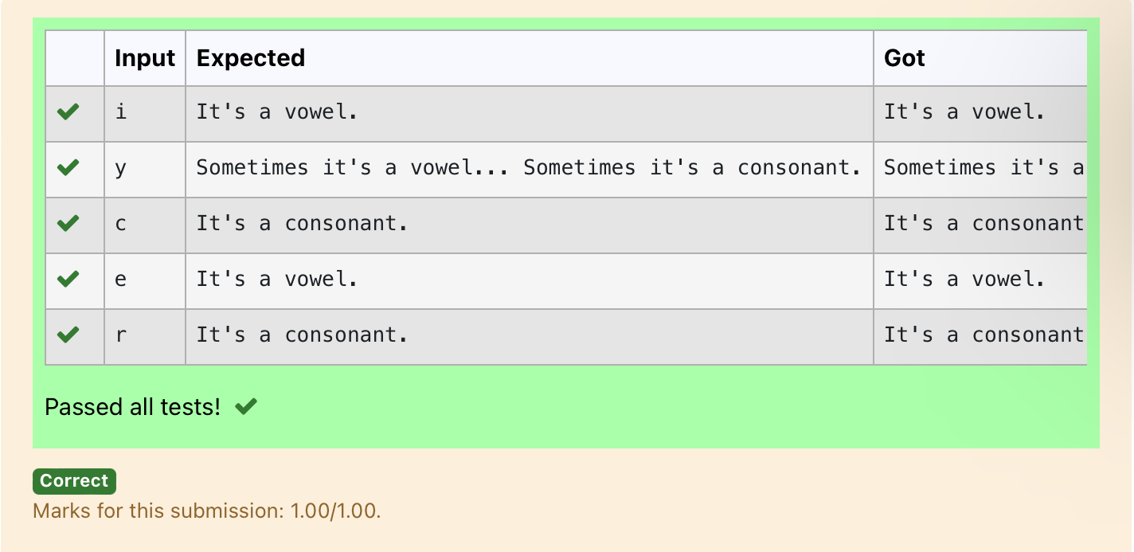

Ex. No. : 3.6 Date: 21.03.2024
Register No.:230401090 Name: MANOJ NJ

Leap Year
Most years have 365 days. However, the time required for the Earth to orbit the Sun is actually slightly more than that. As a result, an extra day, February 29, is included in some years to correct for this difference. Such years are referred to as leap years. The rules for determining whether or not a year is a leap year follow:
• Any year that is divisible by 400 is a leap year.
• Of the remaining years, any year that is divisible by 100 is not a leap year.
• Of the remaining years, any year that is divisible by 4 is a leap year.
• All other years are not leap years.
Write a program that reads a year from the user and displays a message indicating whether or not it is a leap year.
Sample Input 1
1900
Sample Output 1
1900 is not a leap year.
Sample Input 2
2000
Sample Output 2
2000 is a leap year.

year=int(input())
if(year%400==0):
print(year,"is a leap year.")
else:
print(year,"is not a leap year.")

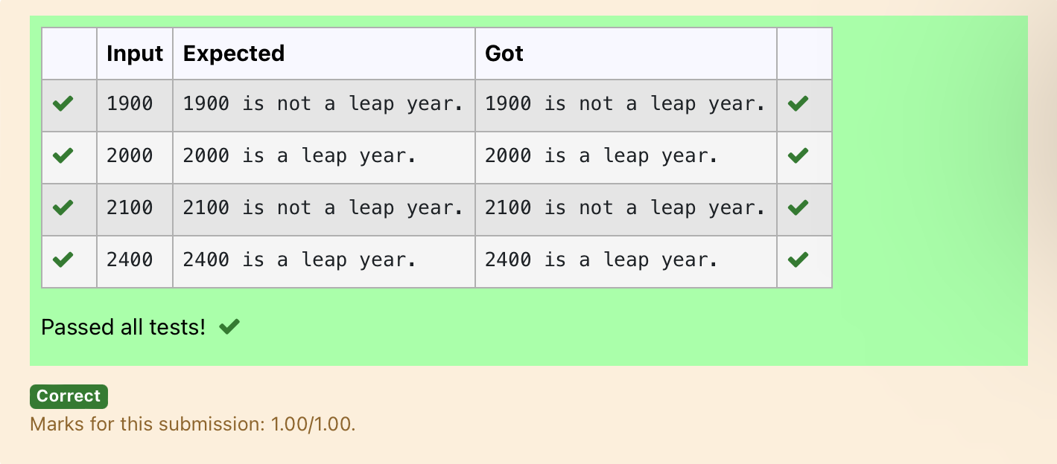

Ex. No. : 3.7 Date: 21.03.2024
Register No.: 230401090 Name: MANOJ NJ

Month name to days
The length of a month varies from 28 to 31 days. In this exercise you will create a program that reads the name of a month from the user as a string. Then your program should display the number of days in that month. Display “28 or 29 days” for February so that leap years are addressed.

Sample Input 1
February
Sample Output 1
February has 28 or 29 days in it.
Sample Input 2
March
Sample Output 2
March has 31 days in it.
Sample Input 3
April
Sample Output 3
April has 30 days in it.
For example:
Input | Result
February | February has 28 or 29 days in it.
March | March has 31 days in it.

m=input()
if(m=="January"):
print(m,"has 31 days in it.")
elif(m=="February"):
print(m,"has 28 or 29 days in it.")
elif(m=="March"):
print(m,"has 31 days in it.")
elif(m=="April"):
print(m,"has 30 days in it.")
elif(m=="May"):
print(m,"has 31 days in it.")
elif(m=="June"):
print(m,"has 30 days in it.")
elif(m=="July"):
print(m,"has 31 days in it.")
elif(m=="August"):
print(m,"has 31 days in it.")
elif(m=="September"):
print(m,"has 30 days in it.")
elif(m=="October"):
print(m,"has 31 days in it.")
elif(m=="November"):
print(m,"has 30 days in it.")
elif(m=="December"):
print(m,"has 31 days in it.")

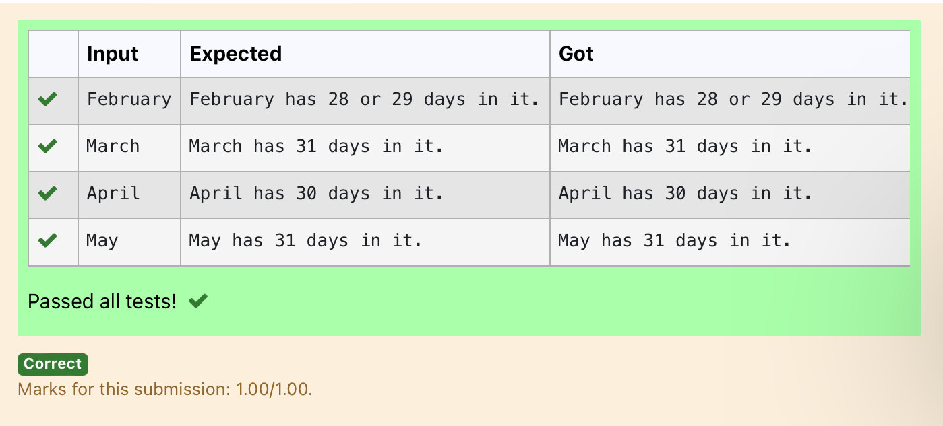

Ex. No. : 3.8 Date: 21.03.2024
Register No.: 230401090 Name: MANOJ NJ

Pythagorean triple
Three numbers form a Pythagorean triple if the sum of squares of two numbers is equal to the square of the third.
For example, 3, 5 and 4 form a Pythagorean triple, since 3*3 + 4*4 = 25 = 5*5
You are given three integers, a, b, and c. They need not be given in increasing order. If they form a Pythagorean triple, then print "Yes", otherwise, print "No".
Sample Input
3
5
4
Sample Output
Yes

For example:
Input | Result
3  4  5 | Yes

a=int(input())
b=int(input())
c=int(input())
if(a*a+b*b==c*c):
print("yes")
elif(a*a+c*c==b*b):
print("yes")
elif(c*c+b*b==a*a):
print("yes")
else:
print("no")
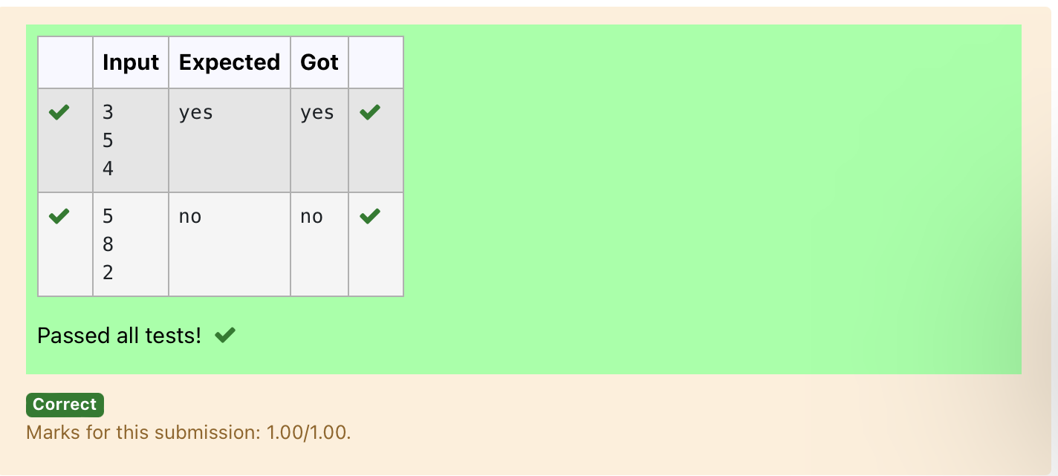

Ex. No. : 3.9 Date: 21.03.2024
Register No.: 230401090 Name: MANOJ NJ

Second last digit
Write a program that returns the second last digit of the given number. Second last digit is being referred 10the digit in the tens place in the given number.
For example, if the given number is 197, the second last digit is 9.
Note1 - The second last digit should be returned as a positive number. i.e. if the given number is -197, the second last digit is 9.
Note2 - If the given number is a single digit number, then the second last digit does not exist. In such cases, the program should return -1. i.e. if the given number is 5, the second last digit should be returned as -1.
For example:
Input | Result
197 | 9

a=int(input())
b=str(abs(a))
l=len(b)
if(l>1):
print(int(b[-2]))
else:
print(-1)

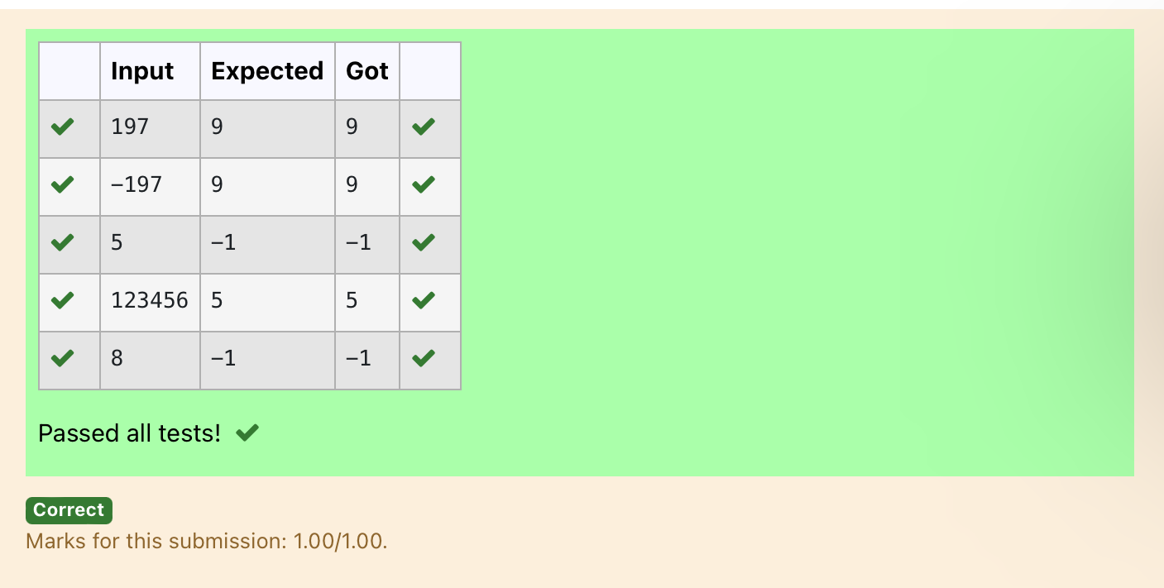

Ex. No. : 3.10 Date: 21.03.2024
Register No.: 230401090 Name: MANOJ NJ

Chinese Zodiac
The Chinese zodiac assigns animals to years in a 12 year cycle. One 12 year cycle is shown in the table below. The pattern repeats from there, with 2012 being another year of the dragon, and 1999 being another year of the hare.
Year Animal
2000 Dragon
2001 Snake
2002 Horse
2003 Sheep
2004 Monkey
2005 Rooster
2006 Dog
2007 Pig
2008 Rat
2009 Ox
2010 Tiger
2011 Hare
Write a program that reads a year from the user and displays the animal associated with that year. Your program should work correctly for any year greater than or equal to zero, not just the ones listed in the table.

Sample Input 1
2010
Sample Output 1
2010 is the year of the Tiger.
Sample Input 2
2020
Sample Output 2
2020 is the year of the Rat.

a=int(input())
b=a%100
c=b%12
if(c==0):
print(a,"is the year of the Dragon.")
elif(c==1):
print(a,"is the year of the Snake.")
elif(c==2):
print(a,"is the year of the Horse.")
elif(c==3):
print(a,"is the year of the Sheep.")
elif(c==4):
print(a,"is the year of the Monkey.")
elif(c==5):
print(a,"is the year of the Rooster.")
elif(c==6):
print(a,"is the year of the Dog.")
elif(c==7):
print(a,"is the year of the Pig.")
elif(c==8):
print(a,"is the year of the Rat.")
elif(c==9):
print(a,"is the year of the Ox.")
elif(c==10):
print(a,"is the year of the Tiger.")
elif(c==11):
print(a,"is the year of the Hare.")

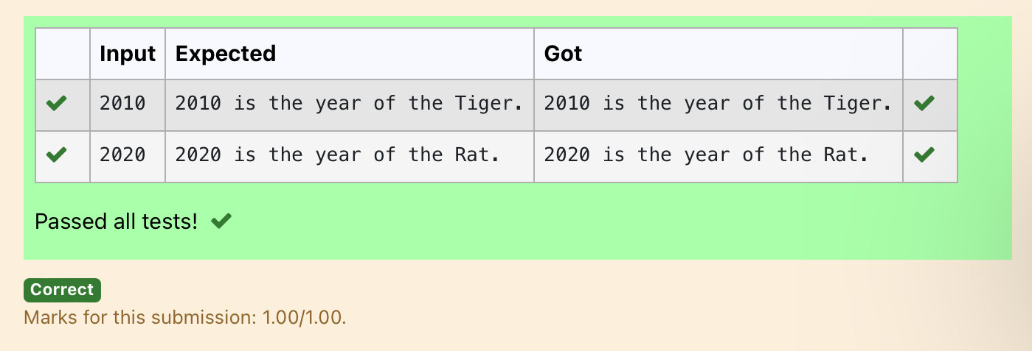

04 - Iteration Control Structures

Ex. No. : 4.1 Date: 28.03.2024
Register No.: 230401090 Name: MANOJ NJ

Factors of a number
Determine the factors of a number (i.e., all positive integer values that evenly divide into a number).
For example:
Input | Result
20 | 1 2 4 5 10 20
k=int(input())
l=[]
for i in range(1,k+1):
if(k%i==0):
l.append(i)
for j in l:
print(j,end=' ')

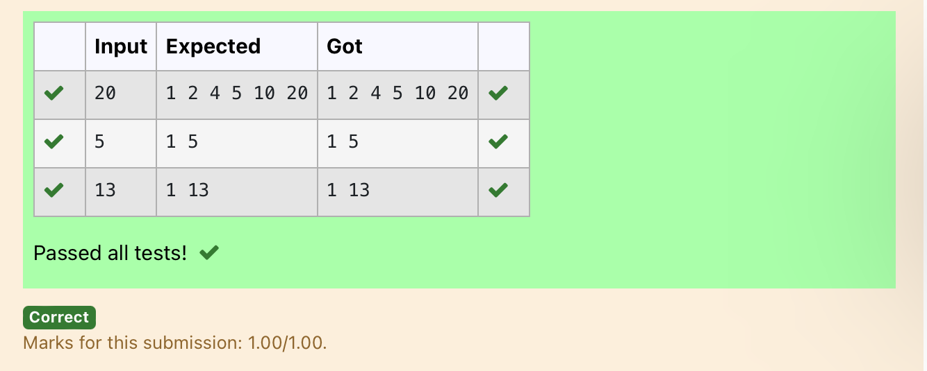

Ex. No. : 4.2 Date: 28.03.2024
Register No.: 230401090 Name: MANOJ NJ

Non Repeated Digit Count
Write a program to find the count of non-repeated digits in a given number N. The number will be passed to the program as an input of type int.
Assumption: The input number will be a positive integer number >= 1 and <= 25000.
Some examples are as below.
If the given number is 292, the program should return 1 because there is only 1 non-repeated digit '9' in this number
If the given number is 1015, the program should return 2 because there are 2 non-repeated digits in this number, '0', and '5'.
If the given number is 108, the program should return 3 because there are 3 non-repeated digits in this number, '1', '0', and '8'.
If the given number is 22, the function should return 0 because there are NO non-repeated digits in this number.

For example:
Input | Result
292 | 1
1015 | 2
108 | 3
22 | 0
n=int(input())
l=[]
k=[]
while n>0:
a=n%10
n=n//10
l.append(a)
for i in range(len(l)):
if l.count(l[i])==1:
k.append(l[i])
print(len(k))

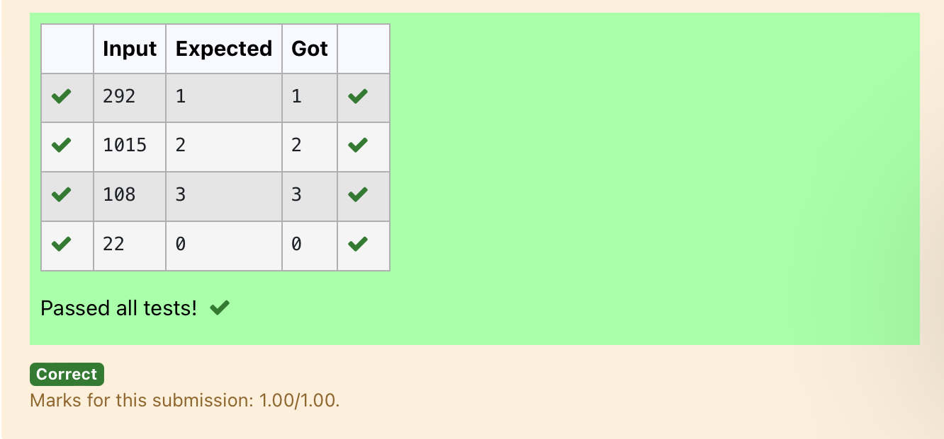

Ex. No. : 4.3 Date: 28.03.2024
Register No.: 230401090 Name: MANOJ NJ

Prime Checking
Write a program that finds whether the given number N is Prime or not. If the number is prime, the program should return 2 else it must return 1.
Assumption: 2 <= N <=5000, where N is the given number.
Example1: if the given number N is 7, the method must return 2
Example2: if the given number N is 10, the method must return 1

For example:
Input | Result
7 | 2
10 | 1

a=int(input())
for i in range(2,a):
if(a%2==0):
flag=0
elif(a%i!=0):
flag=1
else:
flag=0
if(flag==1):
print("2")
elif(flag==0):
print("1")

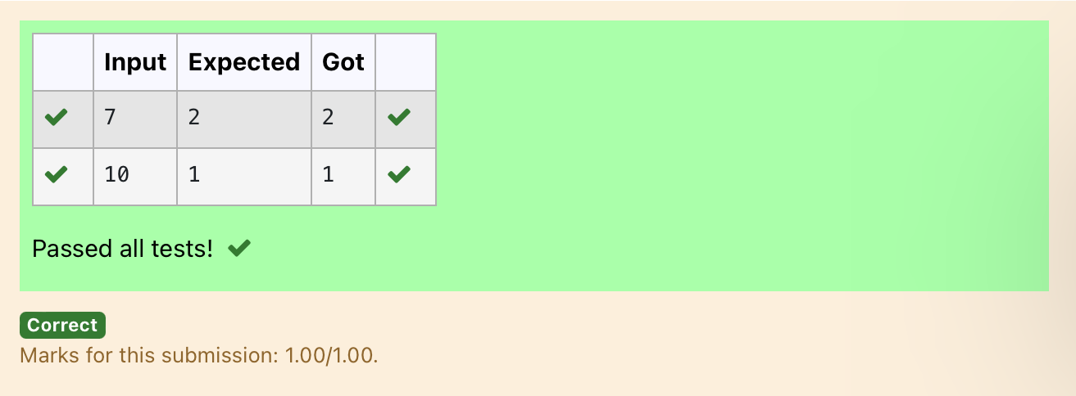

Ex. No. : 4.4 Date: 28.03.2024
Register No.: 230401090 Name: MANOJ NJ

Next Perfect Square
Given a number N, find the next perfect square greater than N.
Input Format:
Integer input from stdin.
Output Format:
Perfect square greater than N.
Example Input:
10
Output:
16

a=int(input())
c=[]
for i in range(0,a):
b=i**2
if(b>a):
c.append(b)
print(c[0])

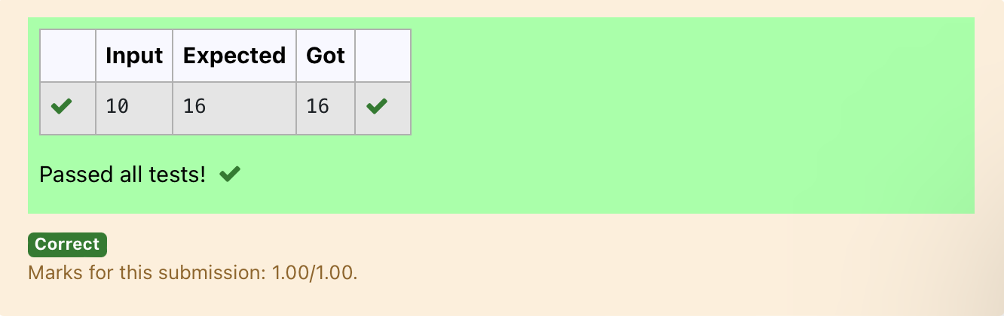

Ex. No. : 4.5 Date: 28.03.2024
Register No.: 230401090 Name: MANOJ NJ

Nth Fibonacci
Write a program to return the nth number in the fibonacci series. The value of N will be passed to the program as input.

NOTE: Fibonacci series looks like –
0, 1, 1, 2, 3, 5, 8, 13, 21, 34, 55, . . . and so on.
i.e. Fibonacci series starts with 0 and 1, and continues generating the next number as the sum of the previous two numbers.
• first Fibonacci number is 0,
• second Fibonacci number is 1,
• third Fibonacci number is 1,
• fourth Fibonacci number is 2,
• fifth Fibonacci number is 3,
• sixth Fibonacci number is 5,
• seventh Fibonacci number is 8, and so on.

For example:
Input:
7
Output
8

a=[0,1]
for i in range(0,100):
a.append(a[-1]+a[-2])
q=int(input())
print(a[q-1])

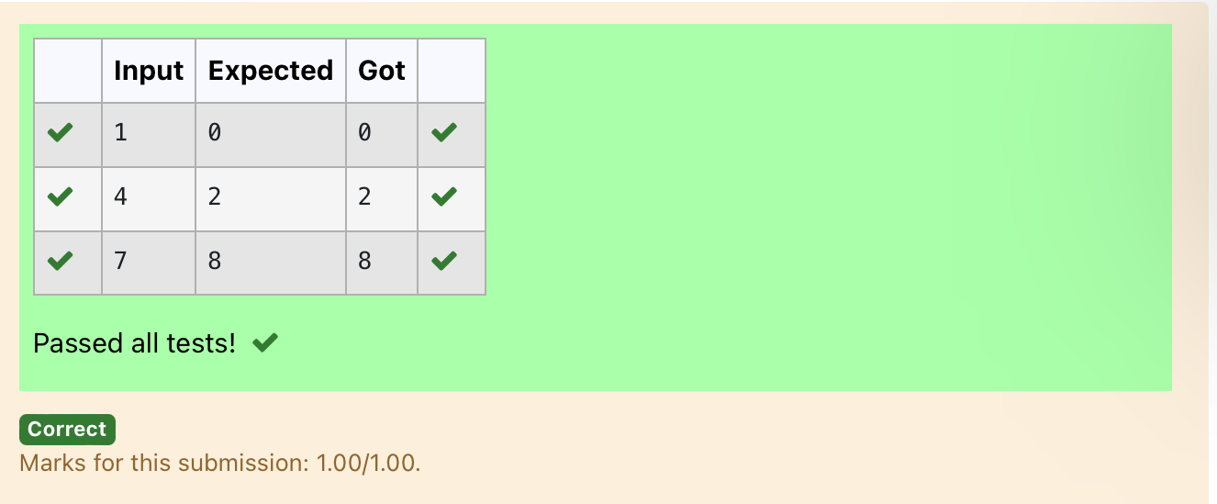

Ex. No. : 4.6 Date: 28.03.2024
Register No.: 230401090 Name : MANOJ NJ

Disarium Number
A Number is said to be Disarium number when the sum of its digit raised to the power of their respective positions becomes equal to the number itself. Write a program to print number is Disarium or not.

Input Format:
Single Integer Input from stdin.
Output Format:
Yes or No.
Example Input:
175
Output:
Yes
Explanation
1^1 + 7^2 +5^3 = 175
Example Input:
123
Output:
No
For example:
Input | Result
175 | Yes
123 | No

import math
n=int(input())
a=len(str(n))
sum=0
x=n
while(x!=0):
r=x%10
sum=int(sum+math.pow(r,a))
a-=1
x=x//10
if(sum==n):
print("Yes")
else:
print("No")

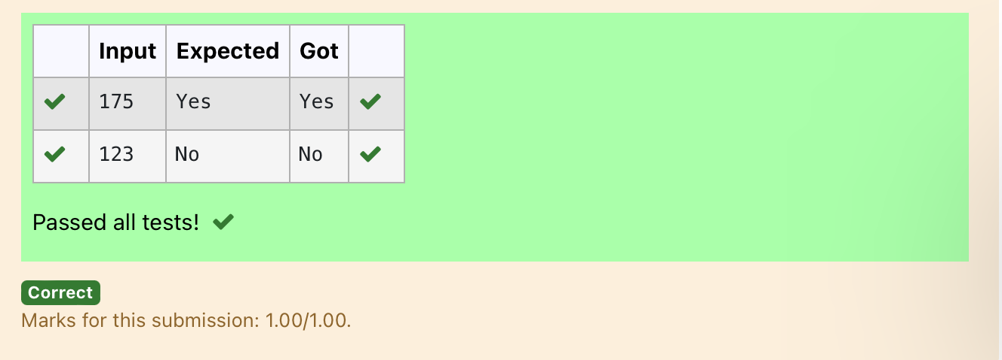

Ex. No. : 4.7 Date: 28.03.2024
Register No.: 230401090 Name: MANOJ NJ

Sum of Series
Write a program to find the sum of the series 1 +11 + 111 + 1111 + . . . + n terms (n will be given as input from the user and sum will be the output)
Sample Test Cases
Test Case 1
Input
4
Output
1234
Explanation:
as input is 4, have to take 4 terms.
1 + 11 + 111 + 1111

Test Case 2
Input
6
Output
123456
For example:
Input | Result
3 | 123
n=int(input())
b=1
sum=0
for i in range(1,n+1):
sum+=b
b=(b*10)+1
print(sum)

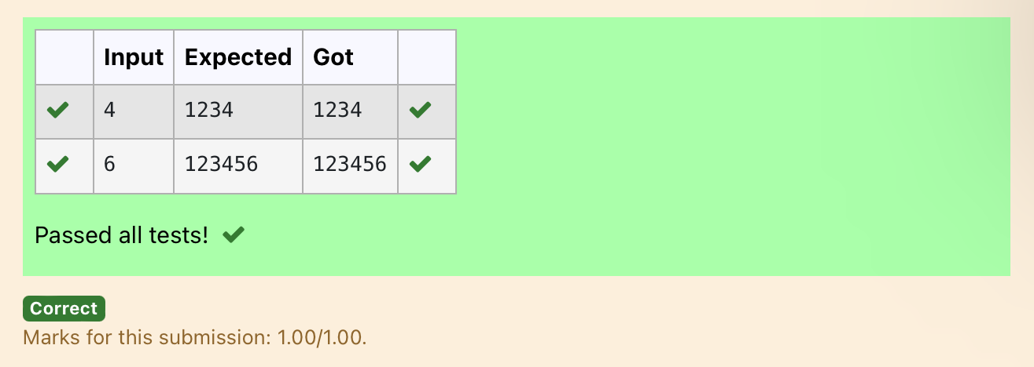

Ex. No. : 4.8 Date: 28.03.2024
Register No.: 230401090 Name: MANOJ NJ

Unique Digit Count
Write a program to find the count of unique digits in a given number N. The number will be passed to the program as an input of type int.
Assumption: The input number will be a positive integer number >= 1 and <= 25000.
For e.g.
If the given number is 292, the program should return 2 because there are only 2 unique digits '2' and '9' in this number
If the given number is 1015, the program should return 3 because there are 3 unique digits in this number, '1', '0', and '5'.
For example:
Input | Result
292 | 2
1015 | 3

a=int(input())
b=[]
while a>0:
c=a%10
a=a//10
b.append(c)
b=list(set(b))
print(len(b))

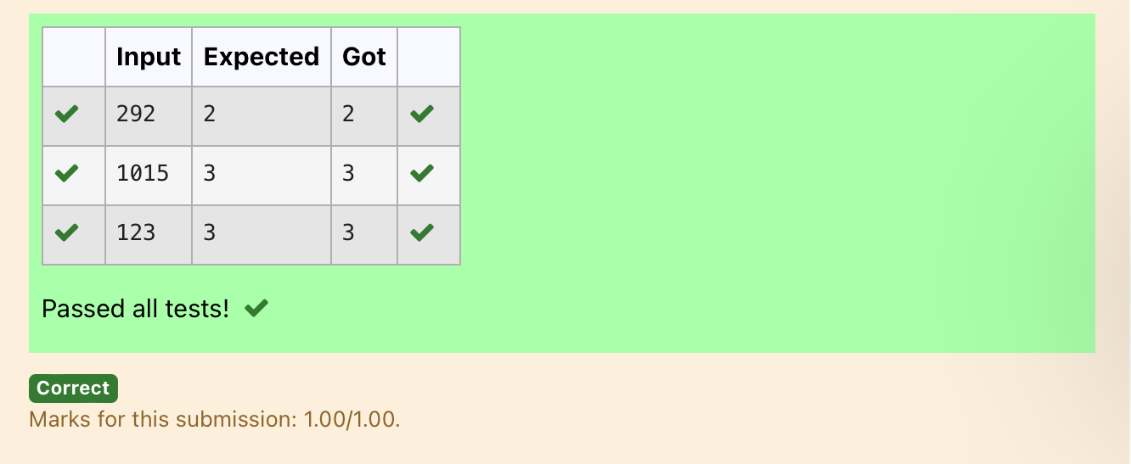

Ex. No. : 4.9 Date: 28.03.2024
Register No.: 230401090 Name: MANOJ NJ

Product of single digit
Given a positive integer N, check whether it can be represented as a product of single digit numbers.
Input Format:
Single Integer input.
Output Format:
Output displays Yes if condition satisfies else prints No.
Example Input:
14
Output:
Yes
Example Input:
13
Output:
No

a=int(input())
flag=0
for i in range(10):
for j in range(10):
if(i*j==a):
flag=1
break
if(flag==1):
print("Yes")
else:
print("No")

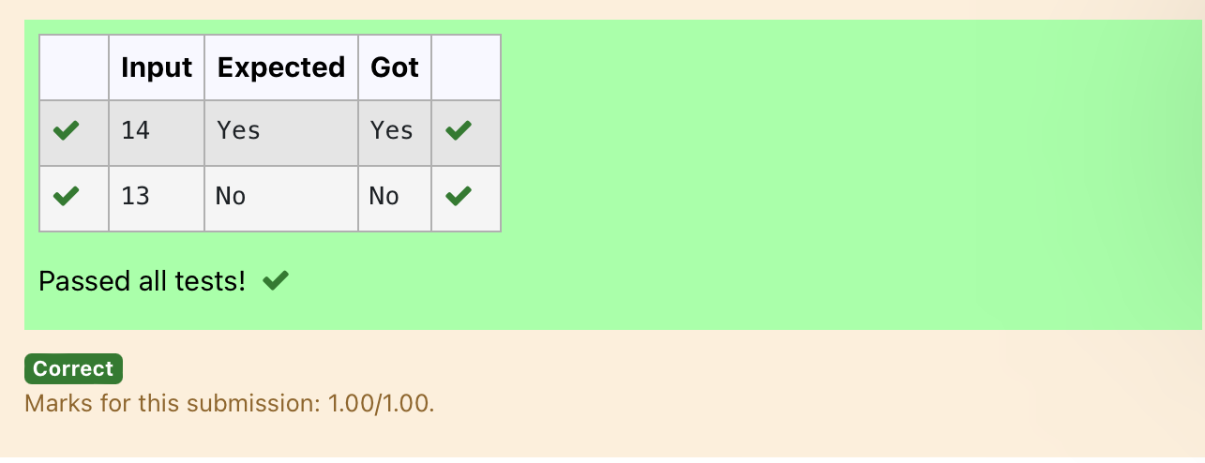

Ex. No. : 4.10 Date: 28.03.2024
Register No.: 230401090 Name: MANOJ NJ

Perfect Square After adding One
Given an integer N, check whether N the given number can be made a perfect square after adding 1 to it.
Input Format:
Single integer input.
Output Format:
Yes or No.
Example Input:
24
Output:
Yes
Example Input:
26
Output:
No
For example:
Input | Result
24 | Yes

import math
n=int(input())
a=n+1
sr=int(math.sqrt(a))
if(sr*sr==a):
print("Yes")
else:
print("No")

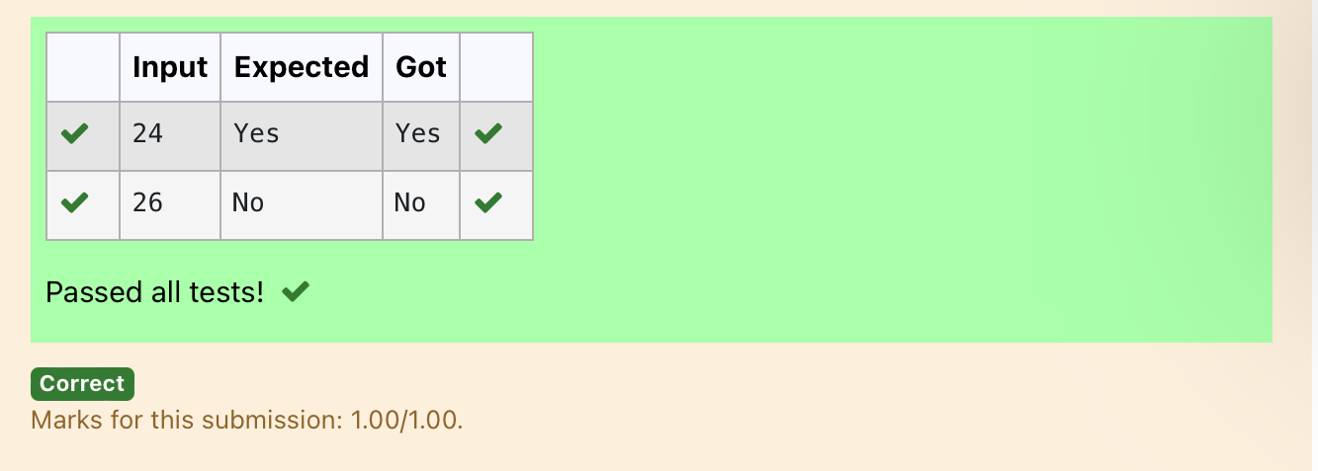

05 - List in Python

Ex. No. : 5.1 Date: 2.4.2024
Register No.: 230401090 Name: MANOJ NJ

Balanced Array
Given an array of numbers, find the index of the smallest array element (the pivot), for which the sums of all elements to the left and to the right are equal. The array may not be reordered.
Example
arr=[1,2,3,4,6]
· the sum of the first three elements, 1+2+3=6. The value of the last element is 6.
· Using zero based indexing, arr[3]=4 is the pivot between the two subarrays.
· The index of the pivot is 3.
Constraints
· 3 ≤ n ≤ 10⁵
· 1 ≤ arr[i] ≤ 2 × 10⁴, where 0 ≤ i < n
· It is guaranteed that a solution always exists.
The first line contains an integer n, the size of the array arr.
Each of the next n lines contains an integer, arr[i], where 0 ≤ i < n.
Sample Case 0
Sample Input 0
4
1
2
3
3
Sample Output 0
2
Explanation 0
The sum of the first two elements, 1+2=3. The value of the last element is 3
Using zero based indexing, arr[2]=3 is the pivot between the two subarrays
The index of the pivot is 2
Sample Case 1
Sample Input 1
3
1
2
1
Sample Output 1
1
Explanation 1
The first and last elements are equal to 1
Using zero based indexing, arr[1]=2 is the pivot between the two subarrays
The index of the pivot is 1.

For example:
Input | Result
4  1  2  3  3 | 2
3  1  2  1 | 1
a=int(input())
l=[]
for i in range(a):
c=int(input())
l.append(c)
for i in range(1,a):
d=sum(l[0:i])
r=sum(l[i+1:])
if(d==r):
print(i)

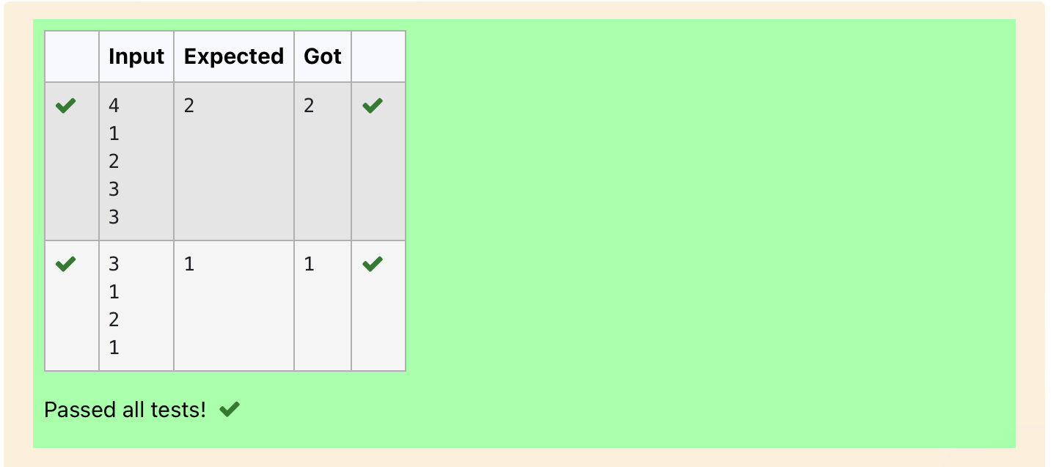

Ex. No. : 5.2 Date: 2.4.2024
Register No.: 230401090 Name: MANOJ NJ

Check pair with difference k
Given an array A of sorted integers and another non negative integer k, find if there exists 2 indices i and j such that A[i] - A[j] = k, i != j.
Input Format
1. First line is number of test cases T. Following T lines contain:
2. N, followed by N integers of the array
3. The non-negative integer k
Output format
Print 1 if such a pair exists and 0 if it doesn’t
Input
1
3
1
3
5
4
Output:
1
Input
1
3
1
3
5
99
Output
0

For example:
Input | Result
1  3  1  3  5  4 | 1
1  3  1  3  5  99 | 0

a=int(input())
while(a!=0):
b=int(input())
l=[]
f=0
for i in range(b):
c=int(input())
l.append(c)
k=int(input())
a-=1
for i in range(b):
for j in range(b):
if(l[i]-l[j]==k and i!=j):
f=1
break
if(f==1):
print(1)
else:
print(0)

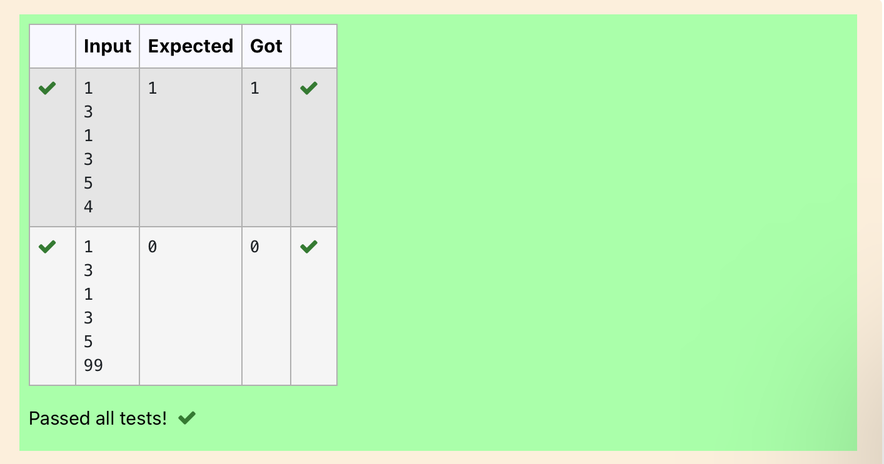

Ex. No. : 5.3 Date: 2.4.2024
Register No.: 230401090 Name: MANOJ NJ

Count Elements
Complete the program to count frequency of each element of an array. Frequency of a particular element will be printed once.
Sample Test Cases
Test Case 1
Input
7
23
45
23
56
45
23
40
Output
23 occurs 3 times
45 occurs 2 times
56 occurs 1 times
40 occurs 1 times

import collections
def CountFrequency(arr):
return collections.Counter(arr)

if __name__ == "__main__":
# Input size of array
n = int(input())

# Input elements in array
arr = []
for _ in range(n):
ele = int(input())
arr.append(ele)

# Calculate frequency of each element
freq = CountFrequency(arr)

for key, value in freq.items():
print(f"{key} occurs {value} times")

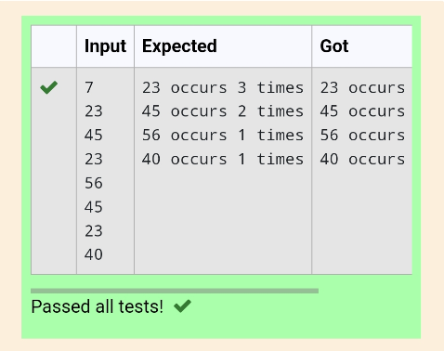

Ex. No. : 5.4 Date: 2.4.2024
Register No.: 230401090 Name: MANOJ NJ

Distinct Elements in an Array
Program to print all the distinct elements in an array. Distinct elements are nothing but the unique (non-duplicate) elements present in the given array.
Input Format:
First line take an Integer input from stdin which is array length n.
Second line take n Integers which is inputs of array.
Output Format:
Print the Distinct Elements in Array in single line which is space Separated

Example Input:
5
1
2
2
3
4
Output:
1 2 3 4
Example Input:
6
1
1
2
2
3
3
Output:
1 2 3

For example:
Input Result
5
1
2
2
3
4
1 2 3 4
6
1
1
2
2
3
3
1 2 3

def merge_arrays_without_duplicates(arr1, arr2):
# Combine the arrays and convert to a set to remove duplicates
result_set = set(arr1 + arr2)
# Convert the set back to a sorted list
merged_sorted_array = sorted(result_set)
return merged_sorted_array

# Input read and processing
def process_input():
# Reading number of elements and the elements for the first array
n1 = int(input())
array1 = []
for _ in range(n1):
element = int(input())
array1.append(element)

# Reading number of elements and the elements for the second array
n2 = int(input())
array2 = []
for _ in range(n2):
element = int(input())
array2.append(element)

# Merge the arrays without duplicates
result = merge_arrays_without_duplicates(array1, array2)

# Print the result
print(" ".join(map(str, result)))

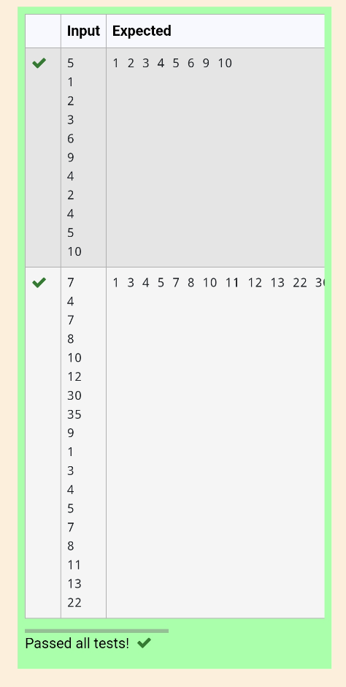

Ex. No. : 5.5 Date: 3.4.2024
Register No.: 230401090 Name: MANOJ NJ

Element Insertion
Consider a program to insert an element / item in the sorted array. Complete the logic by filling up required code in editable section. Consider an array of size 10. The eleventh item is the data is to be inserted.

Sample Test Cases
Test Case 1
Input
1
3
4
5
6
7
8
9
10
11
2

Output
ITEM to be inserted:2
After insertion array is:
1
2
3
4
5
6
7
8
9
10
11

Test Case 2
Input
11
22
33
55
66
77
88
99
110
120
44

Output

ITEM to be inserted:44
After insertion array is:
11
22
33
44
55
66
77
88
99
110
120

def insert_sorted(list, n):
list.append(n)
sorted_list = sorted(list)
print("After insertion array is:")
for i in range(11):
print(sorted_list[i])

sorted_list = [int(input()) for i in range(10)]
new_element = int(input())
print("ITEM to be inserted:", new_element, sep='')
insert_sorted(sorted_list, new_element)

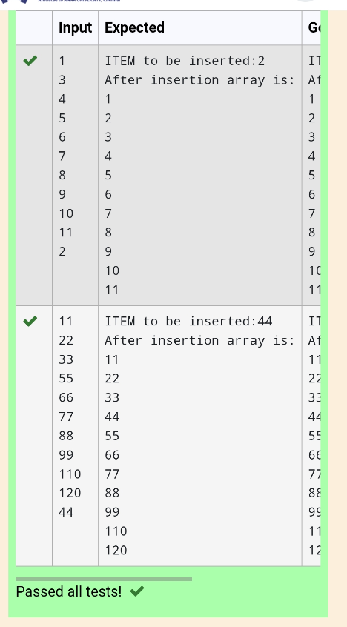

Ex. No. : 5.6 Date: 3.4.2024
Register No.: 230401090 Name: MANOJ NJ

Find the Factor
Determine the factors of a number (i.e., all positive integer values that evenly divide into a number) and then return the p^{th} element of the list, sorted ascending. If there is no p^{th} element, return 0.
Constraints
1 ≤ n ≤ 10¹⁵
1 ≤ p ≤ 10⁹
The first line contains an integer n, the number to factor.
The second line contains an integer p, the 1-based index of the factor to return.

Sample Case 0
Sample Input 0
10
3
Sample Output 0
5
Explanation 0
Factoring n = 10 results in {1, 2, 5, 10}. Return the p = 3rd factor, 5, as the answer.
Sample Case 1
Sample Input 1
10
5
Sample Output 1
0
Explanation 1
Factoring n = 10 results in {1, 2, 5, 10}. There are only 4 factors and p = 5, therefore 0 is returned as the answer.
Sample Case 2
Sample Input 2
1
1
Sample Output 2
1
Explanation 2
Factoring n = 1 results in {1}. The p = 1st factor of 1 is returned as the answer.

For example:
Input | Result
10  3 | 5
10  5 | 0
1  1 | 1

import sys
import math

def find_factors(n):
factors = []
for i in range(1, int(math.sqrt(n)) + 1):
if n % i == 0:
factors.append(i)
if i != n // i:
factors.append(n // i)
return sorted(factors)

def get_pth_factor(n, p):
factors = find_factors(n)
if p <= len(factors):
return factors[p - 1]
else:
return 0

# Reading input directly from the standard input (typically for competitive programming)
input = sys.stdin.read
data = input().split()
n = int(data[0])
p = int(data[1])

# Calculate and print the p-th factor
print(get_pth_factor(n, p))
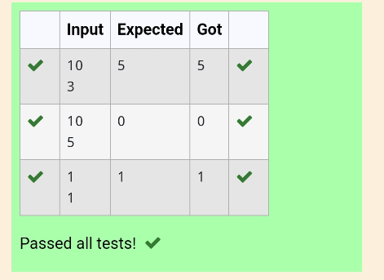

Ex. No. : 5.7 Date: 3.4.2024
Register No.: 230401090 Name: MANOJ NJ

Merge List
Write a Python program to Zip two given lists of lists.

Input:
m : row size
n: column size
list1 and list 2 : Two lists
Output
Zipped List : List which combined both list1 and list2

Sample test case

Sample input
2
2
1
3
5
7
2
4
6
8

Sample Output

[[1, 3, 2, 4], [5, 7, 6, 8]]

def zip_lists(list1, list2):
return [row1 + row2 for row1, row2 in zip(list1, list2)]

def main():
m = int(input())
n = int(input())

list1 = [[int(input()) for _ in range(n)] for _ in range(m)]
list2 = [[int(input()) for _ in range(n)] for _ in range(m)]

zipped_list = zip_lists(list1, list2)
print(zipped_list)

if __name__ == "__main__":
main()
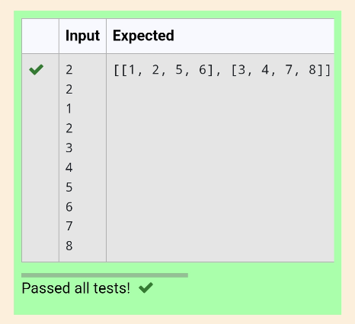

Ex. No. : 5.8 Date: 3.4.2024
Register No.: 230401090 Name: MANOJ NJ

Merge Two Sorted Arrays Without Duplication
Output is a merged array without duplicates.
Input Format
N1 - no of elements in array 1
Array elements for array 1
N2 - no of elements in array 2
Array elements for array2
Output Format
Display the merged array

Sample Input 1

5
1
2
3
6
9
4
2
4
5
10

Sample Output 1

1 2 3 4 5 6 9 10

def merge_arrays_without_duplicates(arr1, arr2):
# Combine the arrays and convert to a set to remove duplicates
result_set = set(arr1 + arr2)
# Convert the set back to a sorted list
merged_sorted_array = sorted(result_set)
return merged_sorted_array

# Input read and processing
def process_input():
# Reading number of elements and the elements for the first array
n1 = int(input())
array1 = []
for _ in range(n1):
element = int(input())
array1.append(element)

# Reading number of elements and the elements for the second array
n2 = int(input())
array2 = []
for _ in range(n2):
element = int(input())
array2.append(element)

# Merge the arrays without duplicates
result = merge_arrays_without_duplicates(array1, array2)

# Print the result
print(" ".join(map(str, result)))

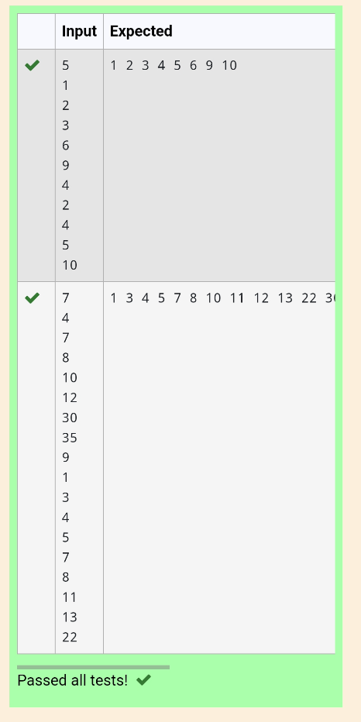

Ex. No. : 5.9 Date: 3.4.2024
Register No.: 230401090 Name: MANOJ NJ

Print Element Location
Write a program to print all the locations at which a particular element (taken as input) is found in a list and also print the total number of times it occurs in the list. The location starts from 1.

For example, if there are 4 elements in the array:
5
6
5
7

If the element to search is 5 then the output will be:
5 is present at location 1
5 is present at location 3
5 is present 2 times in the array.
Sample Test Cases

Test Case 1
Input

4
5
6
5
7
5

Output

5 is present at location 1.
5 is present at location 3.
5 is present 2 times in the array.

Test Case 2
Input
5
67
80
45
97
100
50

Output
50 is not present in the array.

def find_element_locations(lst, target):
locations = []
count = 0
for i in range(len(lst)):
if lst[i] == target:
locations.append(i + 1)
count += 1

return locations, count

def main():
n = int(input())
lst = [int(input()) for _ in range(n)]
target = int(input())

locations, count = find_element_locations(lst, target)

if count == 0:
print(f"{target} is not present in the array.")
else:
for loc in locations:
print(f"{target} is present at location {loc}.")
print(f"{target} is present {count} times in the array.")

if __name__ == "__main__":
main()

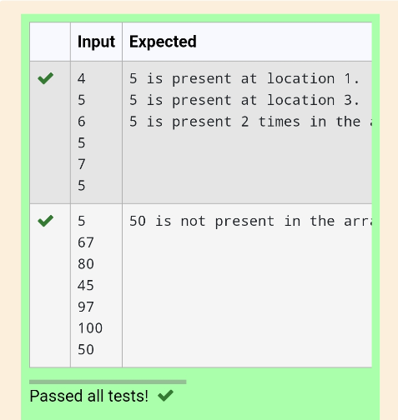

Ex. No. : 5.10 Date: 3.4.2024
Register No.: 230401090 Name: MANOJ NJ

Strictly increasing
Write a Python program to check if a given list is strictly increasing or not. Moreover, If removing only one element from the list results in a strictly increasing list, we still consider the list true
Input:
n : Number of elements
List1: List of values
Output
Print "True" if list is strictly increasing or decreasing else print "False"

Sample Test Case

Input

7

1

2

3

0

4

5

6

Output

True

n= int(input())
arr = [int(input()) for i in range(n)]
l = arr.copy()
g=0
size = len(arr)
arr_asc = sorted(arr)
arr_des = sorted(arr)[::-1]
if arr==arr_asc or arr==arr_des:
print('True')
g=1
else:
for i in arr:
l.remove(i)
arr_asc.remove(i)
arr_des.remove(i)
if l==arr_asc or l==arr_des:
print('True')
g=1
break
l=arr.copy()
arr_asc = sorted(arr)
arr_des = sorted(arr)[::-1]
if g==0:
print('False')

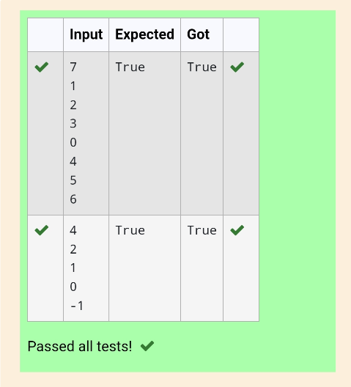

06 - Strings in Python

Ex. No. : 6.1 Date: 30.04.2024
Register No.: 230401090 Name: MANOJ NJ

Count Chars
Write a python program to count all letters, digits, and special symbols respectively from a given string

For example:

Input Result
rec@123
3
3
1

a=input()
c,d,s=0,0,0
for i in range(len(a)):
if(a[i].isalpha()):
c+=1
elif(a[i].isdigit()):
d+=1
else:
s+=1
print(c,d,s,sep="\n")

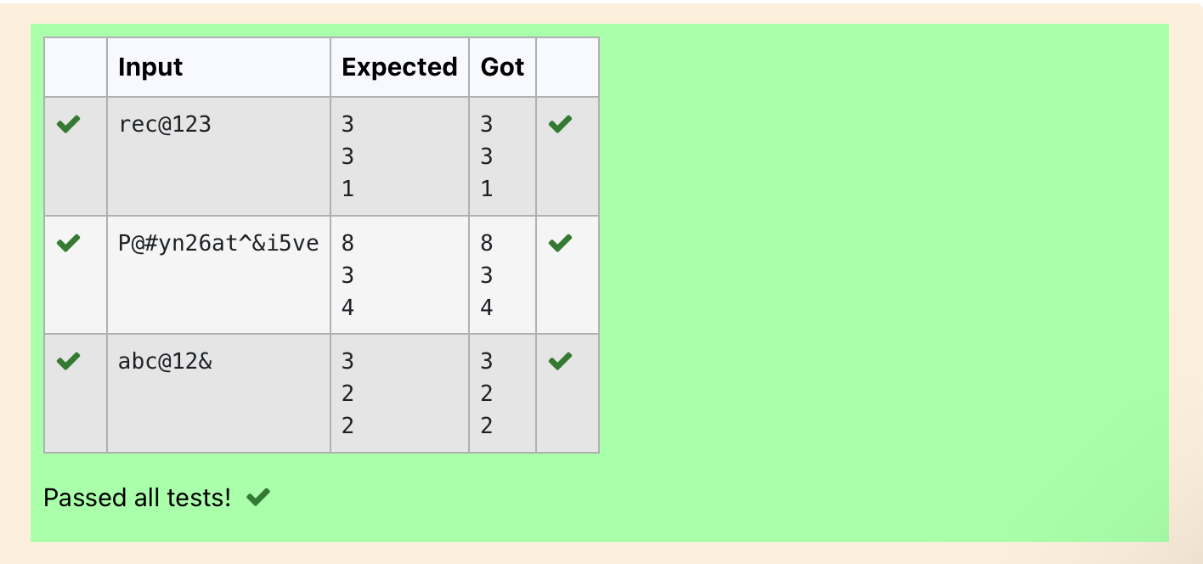

Ex. No. : 6.2 Date: 30.04.2024
Register No.: 230401090 Name: MANOJ NJ

Decompress the String
Assume that the given string has enough memory. Don't use any extra space(IN-PLACE)

Sample Input 1
a2b4c6

Sample Output 1
aabbbbcccccc

import re
a=input()
all=re.findall('\d+',a)
all_w=re.findall('[a-z]',a)
b=''
for i,j in zip(all,all_w):
b+=int(i)*j
print(b)

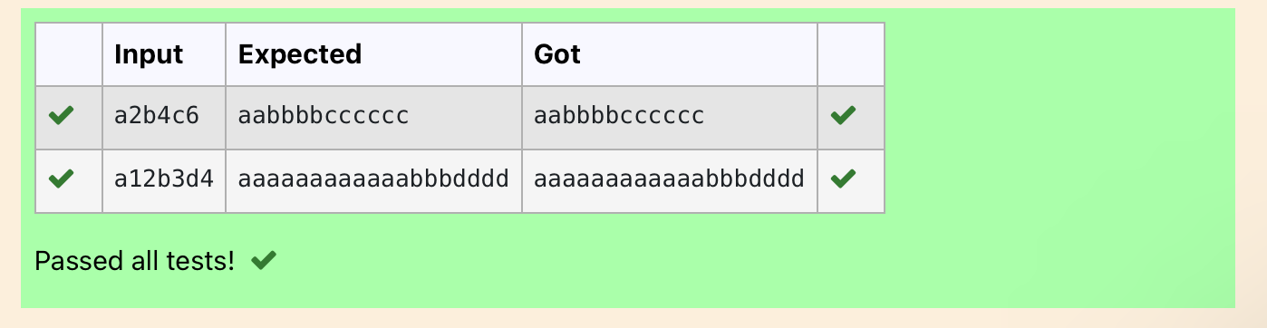

Ex. No. : 6.3 Date: 30.04.2024
Register No.: 230401090 Name: MANOJ NJ

First N Common Chars
Two string values S1, S2 are passed as the input. The program must print first N characters present in S1 which are also present in S2.

Input Format:

The first line contains S1.
The second line contains S2.
The third line contains N.

Output Format:

The first line contains the N characters present in S1 which are also present in S2.

Boundary Conditions:

2 <= N <= 10
2 <= Length of S1, S2 <= 1000

Example Input/Output 1:

Input:

abcbde
cdefghbb
3

Output:

bcd

Note:

b occurs twice in common but must be printed only once.

a=input()
b=input()
C=''
d=int(input())
for i in range(len(a)):
if(len(C)-d==0):
break
else:
if(a[i]in b):
if(a[i] not in C):
C+=a[i]
print (C)

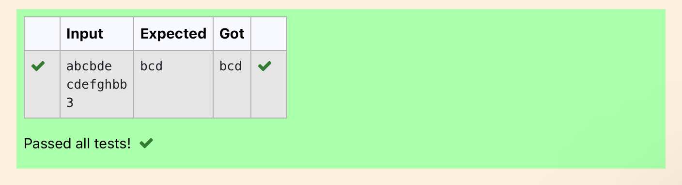

Ex. No. : 6.4 Date: 30.04.2024
Register No.: 230401090 Name: MANOJ NJ

Remove Characters
Given two Strings s1 and s2, remove all the characters from s1 which is present in s2.

Constraints
1<= string length <= 200
Sample Input 1
experience
enc

Sample Output 1
xpri

def remove_chars(s1, s2):
return ''.join([char for char in s1 if char not in s2])
s1=input()
s2=input()
result = remove_chars(s1, s2)
print(result)

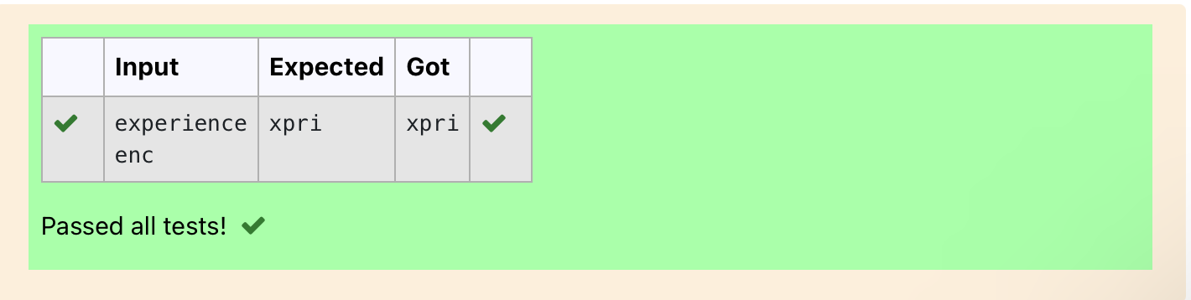

Ex. No. : 6.5 Date: 30.04.24
Register No.: 230401090 Name: MANOJ NJ

Remove Palindrome Words
String should contain only the words are not palindrome.

Sample Input 1
Malayalam is my mother tongue

Sample Output 1
is my mother tongue

For example:

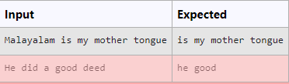

a=[]
a=input()
b=a. split()
for i in b:
k=i.lower()
if k!=k[::-1]:
print(k,end=' ')

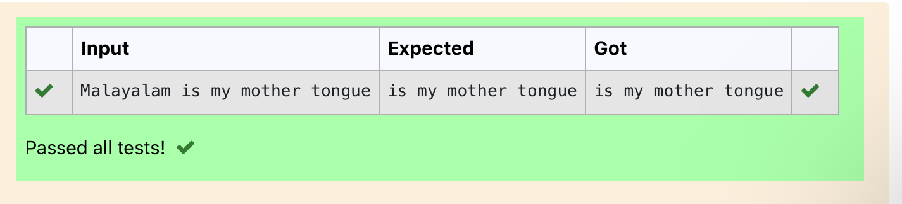

Ex. No. : 6.6 Date: 30.04.24
Register No.: 230401090 Name: MANOJ NJ

Return Second World in Uppercase

Write a program that takes as input a string (sentence), and returns its second word in uppercase.

For example:

If input is “Wipro Technologies Bangalore” the function should return “TECHNOLOGIES”
If input is “Hello World” the function should return “WORLD”
If input is “Hello” the program should return “LESS”

NOTE 1: If input is a sentence with less than 2 words, the program should return the word “LESS”.
NOTE 2: The result should have no leading or trailing spaces.

For example:

Input Result
Wipro Technologies Bangalore
TECHNOLOGIES
Hello World
WORLD
Hello
LESS

f=input()
s=f.split()
if len(s)>1:
c=s[1]
print(c.upper())
else:
print("LESS")

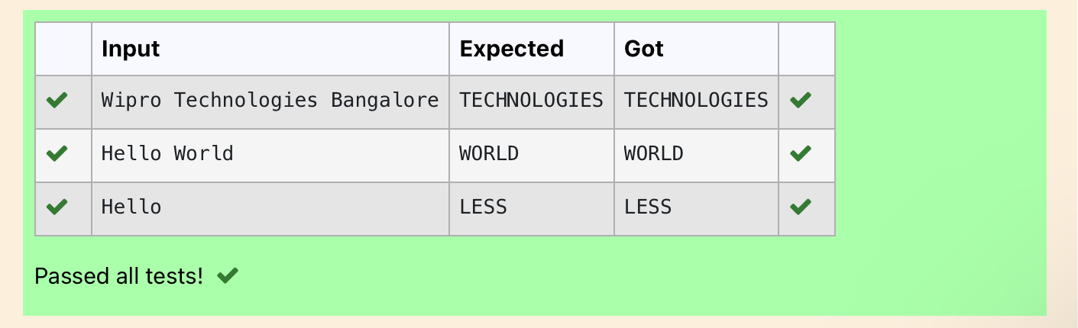

Ex. No. : 6.7 Date: 30.04.2024
Register No.: 230401090 Name: MANOJ NJ

Revers String
Reverse a string without affecting special characters. Given a string S, containing special characters and all the alphabets, reverse the string without affecting the positions of the special characters.

Input:
A&B
Output:
B&A
Explanation: As we ignore '&' and
As we ignore '&' and then reverse, so answer is "B&A".

For example:

Input Result
A&x#
x&A#

def reverse_string(s):
s = list(s)
l, r = 0, len(s) - 1

while l < r:
if not s[l].isalpha():
l += 1
elif not s[r].isalpha():
r -= 1
else:
s[l], s[r] = s[r], s[l]
l += 1
r -= 1

return ''.join(s)

# Test Cases
print(reverse_string(input())) # Output: "B&A"

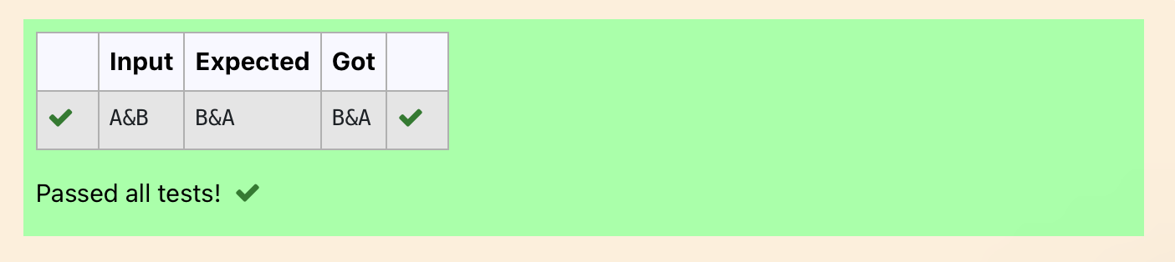

Ex. No. : 6.8 Date: 30.04.2024
Register No.: 230401090 Name: MANOJ NJ

String characters balance Test

Write a program to check if two strings are balanced. For example, strings s1 and s2 are balanced if all the characters in the s1 are present in s2. The character’s position doesn’t matter. If balanced display as "true" ,otherwise "false".

For example:

Input Result
Yn
PYnative
True

a=input()
b=input()
if a in b:
print("True")
else:
print("False")

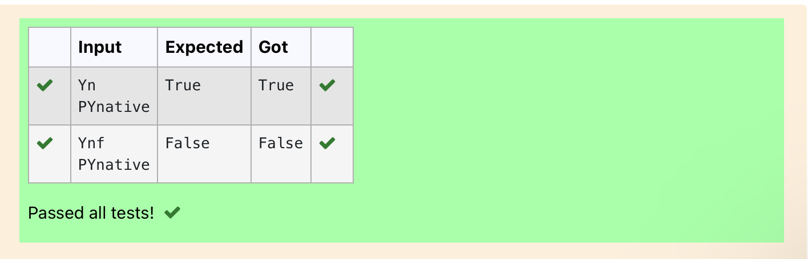

Ex. No. : 6.9 Date: 30.05.2024
Register No.: 230401090 Name: MANOJ NJ

Unique Names

In this exercise, you will create a program that reads words from the user until the user enters a blank line. After the user enters a blank line your program should display each word entered by the user exactly once. The words should be displayed in the same order that they were first entered. For example, if the user enters:
Input:
first
second
first
third
second

then your program should display:

Output:
first
second
third

a,c=[],[]
for i in range(0,5):
b=input()
a.append(b)
for i in range(len(a)):
if(a[i] not in c):
c.append(a[i])
print(a[i])

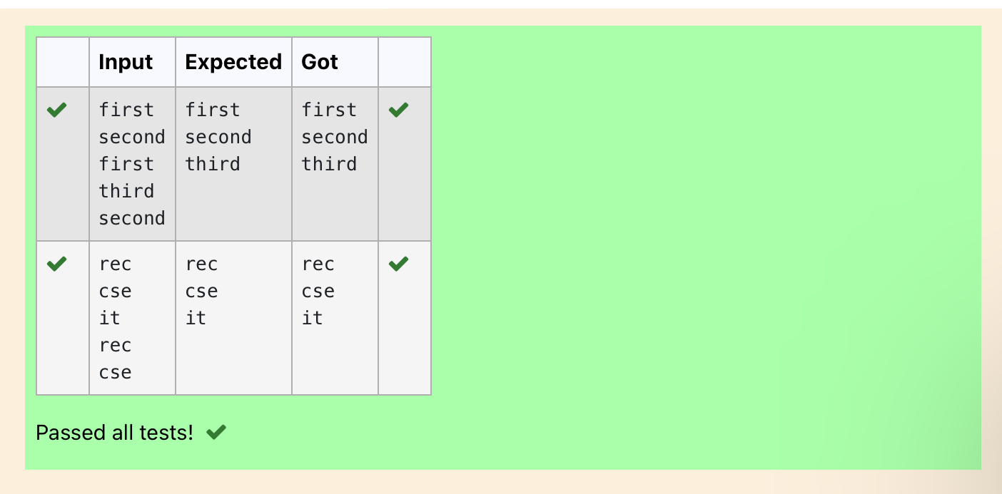

Ex. No. : 6.10 Date: 30.05.2024
Register No.: 230401090 Name: MANOJ NJ
L

Username Domain Extension
Given a string S which is of the format USERNAME@DOMAIN.EXTENSION, the program must print the EXTENSION, DOMAIN, USERNAME in the reverse order.

Input Format:
The first line contains S.

Output Format:
The first line contains EXTENSION.
The second line contains DOMAIN.
The third line contains USERNAME.

Boundary Condition:
1 <= Length of S <= 100

Example Input/Output 1:

Input:

vijayakumar.r@rajalakshmi.edu.in

Output:

edu.in
rajalakshmi
vijayakumar.r

a = input()
ext = a.split('@')[0]
dom = a.split('@')[1].split('.')[0]
userno = a.find('.')
user = a[userno+1:]
print(user)
print(dom, end='\n')
print(ext,end='\n')

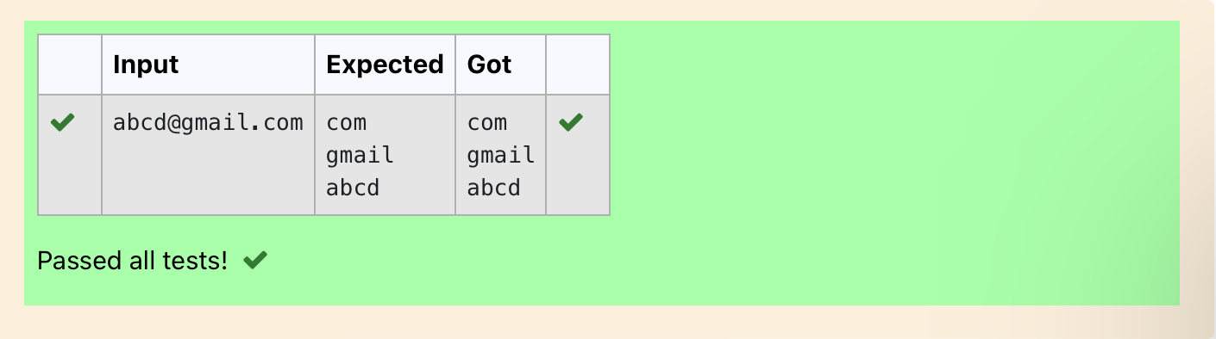

07 - Functions

Ex. No. : 7.1 Date: 23.05.2024
Register No.: 230401090 Name: MANOJ NJ

Abundant Number
An abundant number is a number for which the sum of its proper divisors is greater than the number itself. Proper divisors of the number are those that are strictly lesser than the number.

Input Format:
Take input an integer from stdin
Output Format:
Return Yes if given number is Abundant. Otherwise, print No
Example input:
12
Output:
Yes
Explanation
The proper divisors of 12 are: 1, 2, 3, 4, 6, whose sum is 1 + 2 + 3 + 4 + 6 = 16. Since sum of proper divisors is greater than the given number, 12 is an abundant number.
Example input:
13
Output:
No
Explanation
The proper divisors of 13 is: 1, whose sum is 1. Since sum of proper divisors is not greater than the given number, 13 is not an abundant number.

For example:
Test Result
print(abundant(12)) Yes
print(abundant(13)) No
def abundant(n):
l,s=[],0
for i in range(1,int(n//2)+1):
if(n%i==0):
l.append(i)
for i in l:
s+=i
if(s>n):
return("Yes")
else:
return("No")
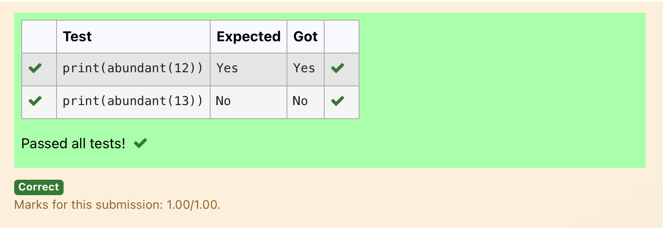

Ex. No. : 7.2 Date: 1.06.2024
Register No.: 230401090 Name: MANOJ NJ

Automorphic number or not
An automorphic number is a number whose square ends with the number itself. For example, 5 is an automorphic number because 5*5 =25. The last digit is 5 which same as the given number.

If the number is not valid, it should display “Invalid input”.
If it is an automorphic number display “Automorphic” else display “Not Automorphic”.

Input Format:
Take a Integer from Stdin
Output Format:
Print Automorphic if given number is Automorphic number, otherwise Not Automorphic
Example input: 5 Output: Automorphic Example input: 25 Output: Automorphic Example input: 7 Output: Not Automorphic
For example:
Test Result
print(automorphic(5)) Automorphic

def automorphic(n):
a=str(n*n)
if(int(a[-1])==n):
return("Automorphic")
else:
return("Not Automorphic")
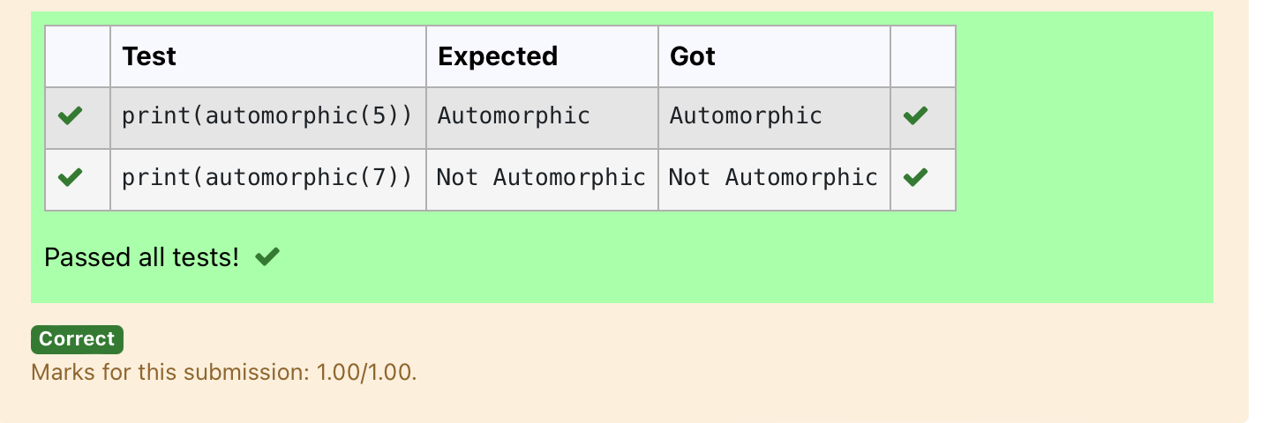

Ex. No. : 7.3 Date: 1.06.2024
Register No.: 230401090 Name: MANOJ NJ

Check Product of Digits
Write a code to check whether product of digits at even places is divisible by sum of digits at odd place of a positive integer.
Input Format:

Take an input integer from stdin.

Output Format:

Print TRUE or FALSE.

Example Input:

1256

Output:

TRUE

Example Input:

1595

Output:

FALSE

For example:

Test | Result
print(productDigits(1256)) | True
print(productDigits(1595)) | False

def productDigits(n):
a=str(n)
s,p=0,1
for i in range(0,len(a),2):
s+=int(a[i])
for i in range(1,len(a),2):
p*=int(a[i])
if(p%s==0):
return("True")
else:
return("False")
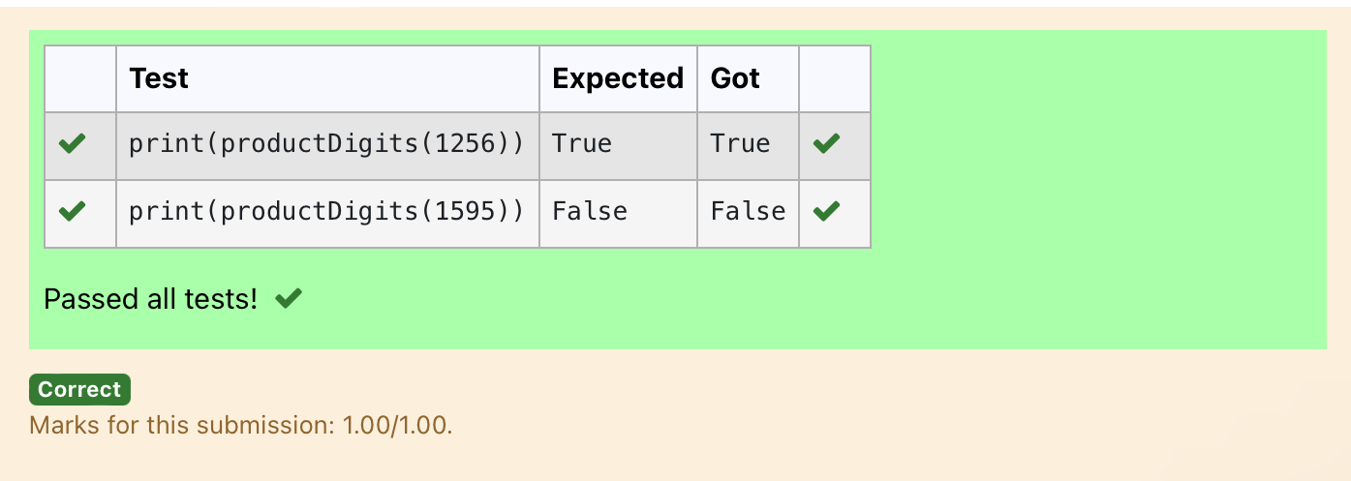

Ex. No. : 7.4 Date: 1.06.2024
Register No.: 230401090 Name: MANOJ NJ

Christmas Discount
An e-commerce company plans to give their customers a special discount for Christmas.
They are planning to offer a flat discount. The discount value is calculated as the sum of all the prime digits in the total bill amount.
Write an python code to find the discount value for the given total bill amount.
Constraints
1 <= orderValue< 10e¹⁰⁰⁰⁰⁰
Input
The input consists of an integer orderValue, representing the total bill amount.
Output
Print an integer representing the discount value for the given total bill amount.
Example Input
578
Output
12
For example:
Test | Result
print(christmasDiscount(578)) | 12

def christmasDiscount(n):
res=0
while n!=0:
rem=n%10
flag=0
for i in range(1,rem+1):
if rem%i==0:
flag+=1
if flag==2:
res=res+rem
n=n//10

return res
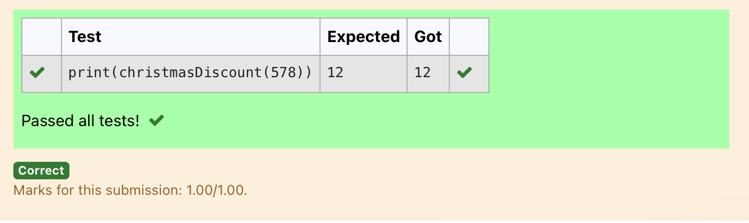

Ex. No. : 7.5 Date: 1.06.2024
Register No.: 230401090 Name: MANOJ NJ

Coin Change
complete function to implement coin change making problem i.e. finding the minimum
number of coins of certain denominations that add up to given amount of money.
The only available coins are of values 1, 2, 3, 4
Input Format:
Integer input from stdin.
Output Format:
return the minimum number of coins required to meet the given target.
Example Input:
16
Output:
4
Explanation:
We need only 4 coins of value 4 each
Example Input:
25
Output:
7
Explanation:
We need 6 coins of 4 value, and 1 coin of 1 value

def coinChange(amount):
# Available coin denominations
coins = [1, 2, 3, 4]
# Initialize a list to store the minimum number of coins for each amount from 0 to the target amount
dp = [float('inf')] * (amount + 1)
dp[0] = 0 # Base case: 0 coins needed to make amount 0

# Iterate through all amounts from 1 to the target amount
for i in range(1, amount + 1):
# Iterate through all available coin denominations
for coin in coins:
# If the current coin denomination is less than or equal to the current amount
if coin <= i:
# Update dp[i] to be the minimum between its current value and dp[i - coin] + 1
dp[i] = min(dp[i], dp[i - coin] + 1)

# The result is stored at dp[amount]
return dp[amount]
amount = int(input())
print(coinChange(amount))
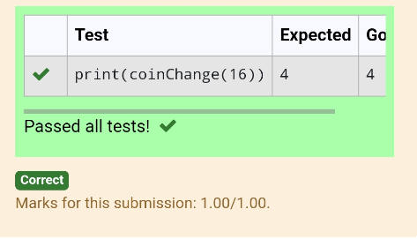

Ex. No. : 7.6 Date: 1.06.2024
Register No.: 230401090 Name: MANOJ NJ

Difference Sum
Given a number with maximum of 100 digits as input, find the difference between the sum of odd and even position digits.
Input Format:
Take a number in the form of String from stdin.
Output Format:
Print the difference between sum of even and odd digits
Example input:
1453
Output:
1
Explanation:
Here, sum of even digits is 4 + 3 = 7
sum of odd digits is 1 + 5 = 6.
Difference is 1.
Note that we are always taking absolute difference
def differenceSum(n):
a=[]
b=[]
k=str(n)
for i in range(len(k)):
if int(i)%2==0:
a.append(int(k[i]))
else:
b.append(int(k[i]))
s=sum(b)
r=sum(a)
j=s-r
return j
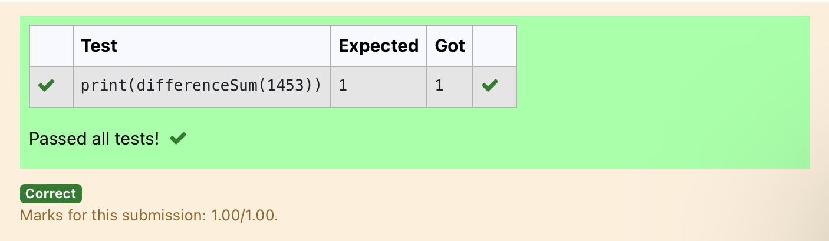

Ex. No. : 7.7 Date: 1.06.2024
Register No.: 230401090 Name: MANOJ NJ

Ugly number

A number is considered to be ugly if its only prime factors are 2, 3 or 5.
[1, 2, 3, 4, 5, 6, 8, 9, 10, 12, 15, …] is the sequence of ugly numbers.
Task:
complete the function which takes a number n as input and checks if it's an ugly number. return ugly if it is ugly, else return not ugly
Hint:
An ugly number U can be expressed as: U = 2^a * 3^b * 5^c, where a, b and c are nonnegative integers.
For example:
Test | Result
print(checkUgly(6)) | ugly
print(checkUgly(21)) | not ugly

def checkUgly(n):
for i in range(n):
for j in range(n):
for k in range(n):
if(n==(2**i)+(3**j)+(5**k)):
return("ugly")
return("not ugly")
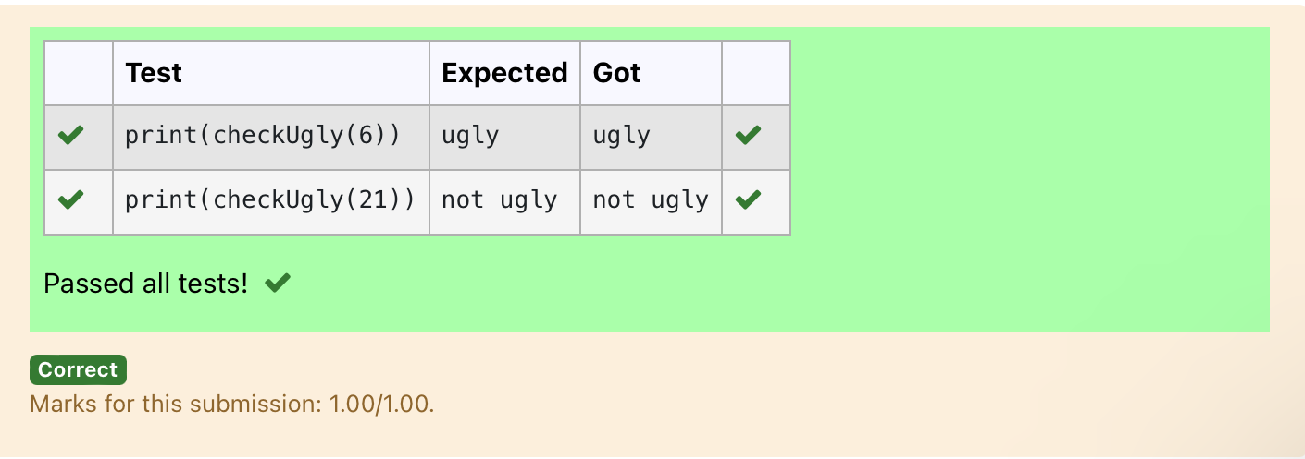

08 – Tuple/Set

Ex. No. : 8.1 Date: 13.06.2024
Register No.: 230401090 Name: MANOJ NJ

Binary String
Coders here is a simple task for you, Given string str. Your task is to check whether it is a binary string or not by using python set.

Examples:
Input: str = "01010101010"
Output: Yes

Input: str = "REC101"
Output: No

For example:
Input | Result
01010101010 | Yes
010101 10101 | No

a = input()
try:
c = int(a)
print("Yes")
except:
print("No")

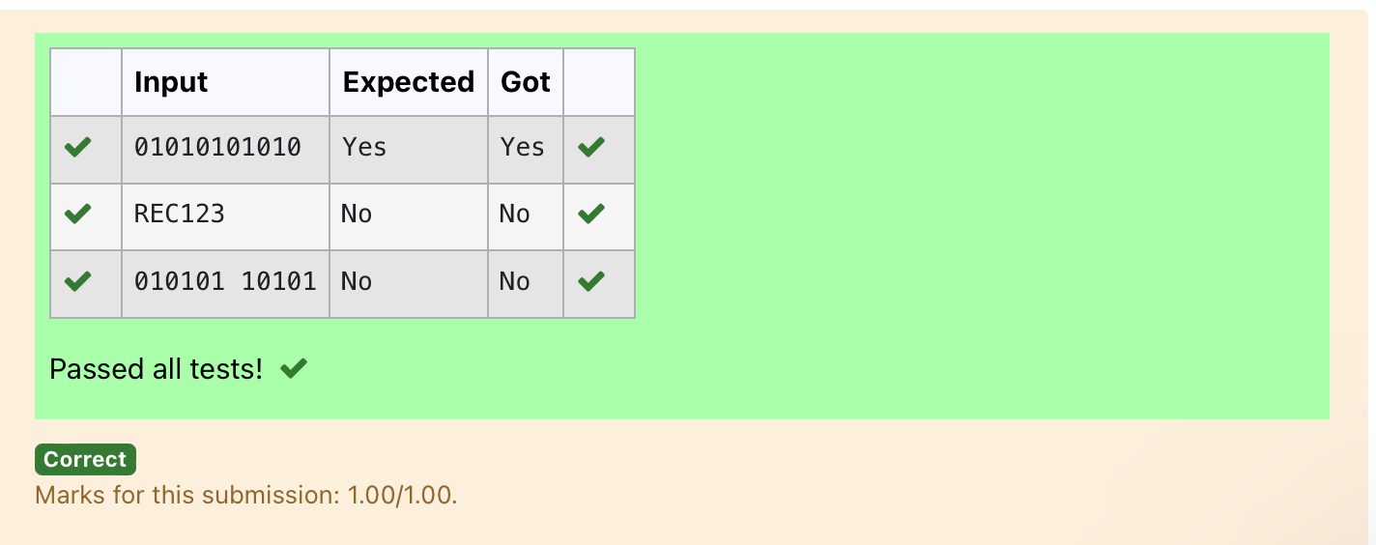

Ex. No. : 8.2 Date: 13.06.2024
Register No.: 230401090 Name: MANOJ NJ

Check Pair
Given a tuple and a positive integer k, the task is to find the count of distinct pairs in the tuple whose sum is equal to K.
Examples:
Input: t = (5, 6, 5, 7, 7, 8 ), K = 13
Output: 2
Explanation:
Pairs with sum K( = 13) are {(5, 8), (6, 7), (6, 7)}.
Therefore, distinct pairs with sum K( = 13) are { (5, 8), (6, 7) }.
Therefore, the required output is 2.

For example:
Input | Result
1,2,1,2,5  3 | 1
1,2  0 | 0

t = input()
k = int(input())
a = t.split(",")
l = [int(x) for x in a]
count = 0
x = set()

for i in range(len(l)):
for j in range(i + 1, len(l)):
if l[i] + l[j] == k:
s = (l[i], l[j])
if s not in x and (l[j], l[i]) not in x:
count += 1
x.add(s)

print(count)

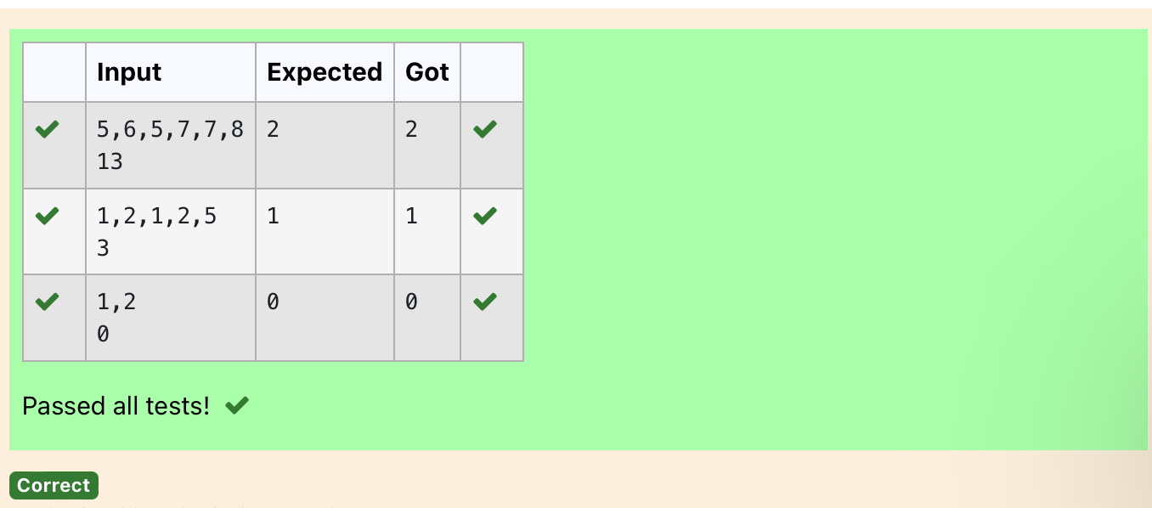

Ex. No. : 8.3 Date: 13.06.2024
Register No.: 230401090 Name: MANOJ NJ

DNA Sequence
The DNA sequence is composed of a series of nucleotides abbreviated as 'A', 'C', 'G', and 'T'.
For example, "ACGAATTCCG" is a DNA sequence.
When studying DNA, it is useful to identify repeated sequences within the DNA.
Given a string s that represents a DNA sequence, return all the 10-letter-long sequences (substrings) that occur more than once in a DNA molecule. You may return the answer in any order.

Example 1:
Input: s = "AAAAACCCCCAAAAACCCCCCAAAAAGGGTTT"
Output: ["AAAAACCCCC","CCCCCAAAAA"]
Example 2:
Input: s = "AAAAAAAAAAAAA"
Output: ["AAAAAAAAAA"]

For example:
Input | Result
AAAAACCCCCAAAAACCCCCCAAAAAGGGTTT | AAAAACCCCC  CCCCCAAAAA

s = input()
j = []
repeated = set()
for i in range(len(s) - 9):
sequence = s[i:i+10]
if sequence in j:
repeated.add(sequence)
else:
j.append(sequence)
l=list(repeated)
l=list(reversed(l))
for i in l:
print(i)

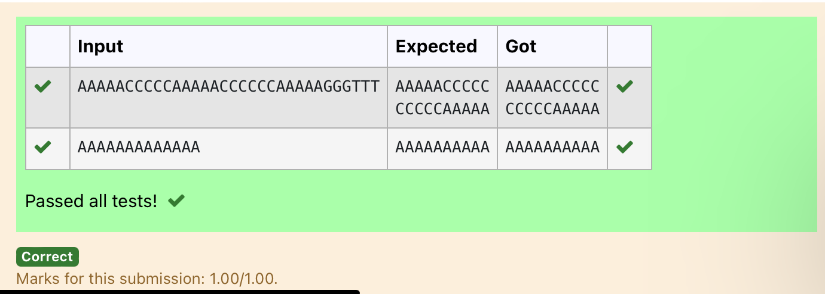

Ex. No. : 8.4 Date: 13.06.2024
Register No.: 230401090 Name: MANOJ NJ

Print repeated no
Given an array of integers nums containing n + 1 integers where each integer is in the range [1, n] inclusive.There is only one repeated number in nums, return this repeated number. Solve the problem using set.
Example 1:
Input: nums = [1,3,4,2,2]
Output: 2

Example 2:
Input: nums = [3,1,3,4,2]
Output: 3

For example:
Input | Result
1 3 4 4 2 | 4

n =input().split(" ")
n = list(n)
for i in range(len(n)):
for j in range(i+1,len(n)):
if n[i] == n[j]:
print(n[i])
exit(0)
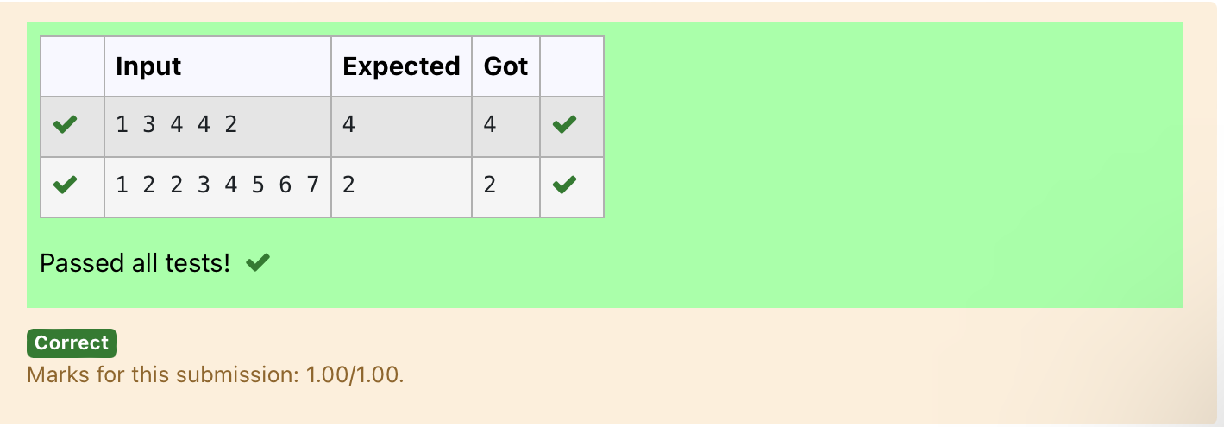

Ex. No. : 8.5 Date: 13.06.2024
Register No.: 230401090 Name: MANOJ NJ

Remove repeated
Write a program to eliminate the common elements in the given 2 arrays and print only the non-repeating elements and the total number of such non-repeating elements.
Input Format:
The first line contains space-separated values, denoting the size of the two arrays in integer format respectively.
The next two lines contain the space-separated integer arrays to be compared.

Sample Input:
5 4
1 2 8 6 5
2 6 8 10
Sample Output:
1 5 10
3
Sample Input:
5 5
1 2 3 4 5
1 2 3 4 5
Sample Output:
NO SUCH ELEMENTS

For example:
Input | Result
5 4  1 2 8 6 5  2 6 8 10 | 1 5 10  3
a=input()
d=[]
b=input()
c=input()
b=tuple(b.split(" "))
c=tuple(c.split(" "))
for i in b:
if i not in c:
d.append(i)
for i in c:
if i not in b:
d.append(i)
for i in range(len(d)):
print(int(d[i]),end=' ')
print()
print(len(d))
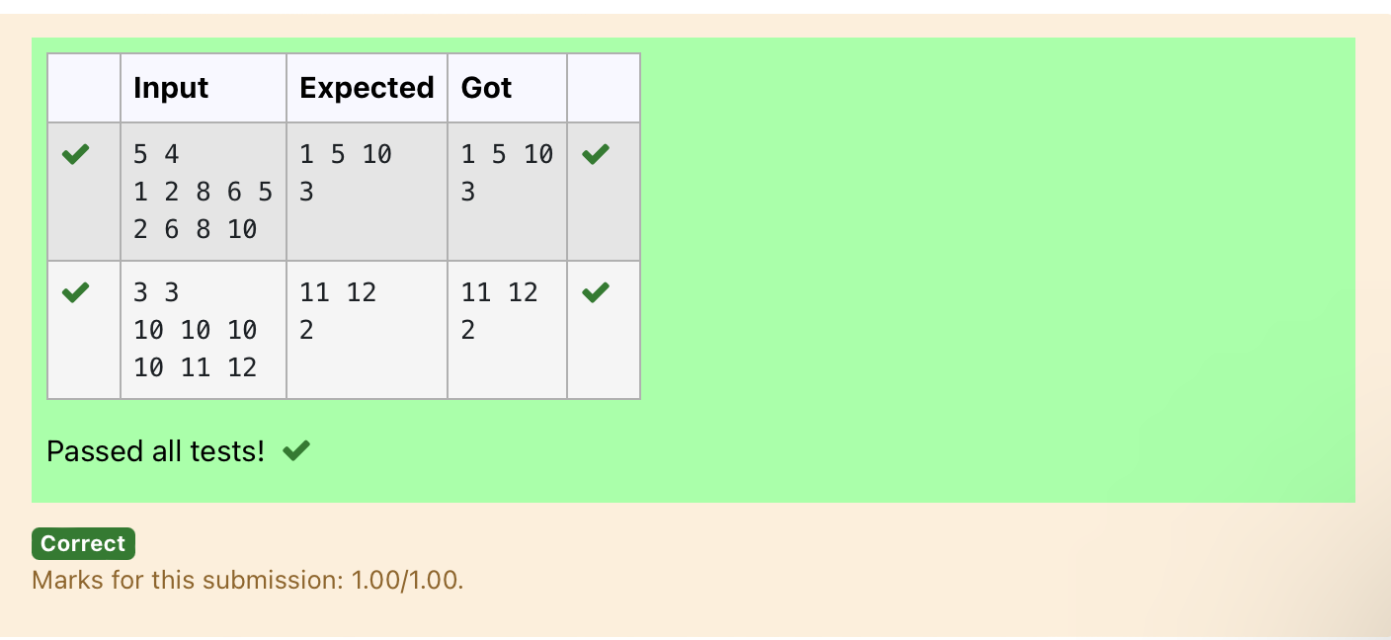

Ex. No. : 8.6 Date: 13.06.2024
Register No.: 231501149 Name: MANOJ NJ

Malfunctioning Keyboard
There is a malfunctioning keyboard where some letter keys do not work. All other keys on the keyboard work properly.
Given a string text of words separated by a single space (no leading or trailing spaces) and a string brokenLetters of all distinct letter keys that are broken, return the number of words in text you can fully type using this keyboard.
Example 1:
Input: text = "hello world", brokenLetters = "ad"
Output:
1
Explanation: We cannot type "world" because the 'd' key is broken.

For example:
Input | Result
hello world  ad | 1

a=input()
b=input()
c=set()
for i in a:
for j in b:
if j in i:
c.add(i)
print(len(c))
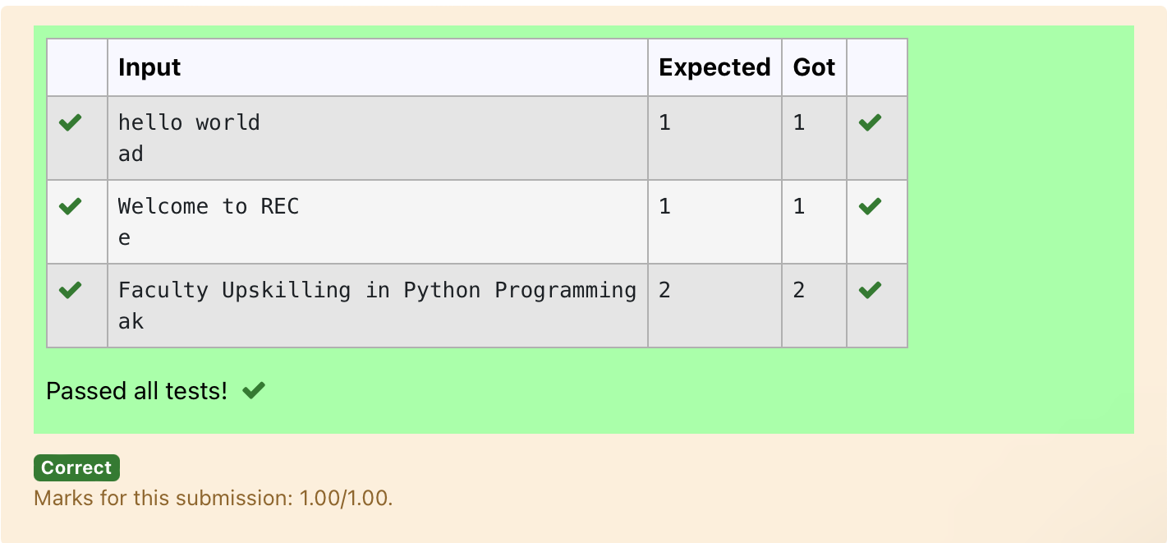

Ex. No. : 8.7 Date: 22.05.2024
Register No.: 230401090 Name: MANOJ NJ

American keyboard
Given an array of strings words, return the words that can be typed using letters of the alphabet on only one row of American keyboard like the image below.
In the American keyboard:
- the first row consists of the characters "qwertyuiop",
- the second row consists of the characters "asdfghjkl", and
- the third row consists of the characters "zxcvbnm"
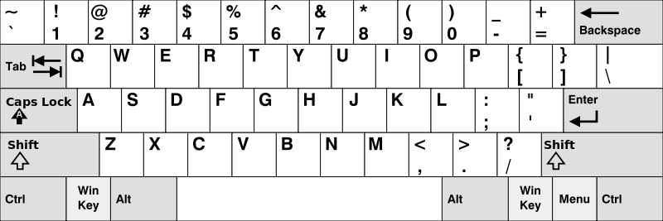

Example 1:
Input: words = ["Hello","Alaska","Dad","Peace"]
Output: ["Alaska","Dad"]
Example 2:
Input: words = ["omk"]
Output: []
Example 3:
Input: words = ["adsdf","sfd"]
Output: ["adsdf","sfd"]

For example:
Input | Result
4  Hello  Alaska  Dad  Peace | Alaska  Dad

def findWords(words):
row1 = set('qwertyuiop')
row2 = set('asdfghjkl')
row3 = set('zxcvbnm')

result = []
for word in words:
w = set(word.lower())
if w.issubset(row1) or w.issubset(row2) or w.issubset(row3):
result.append(word)
if len(result) == 0:
print("No words")
else:
for i in result:
print(i)

a = int(input())
arr = [input() for i in range(a)]
findWords(arr)
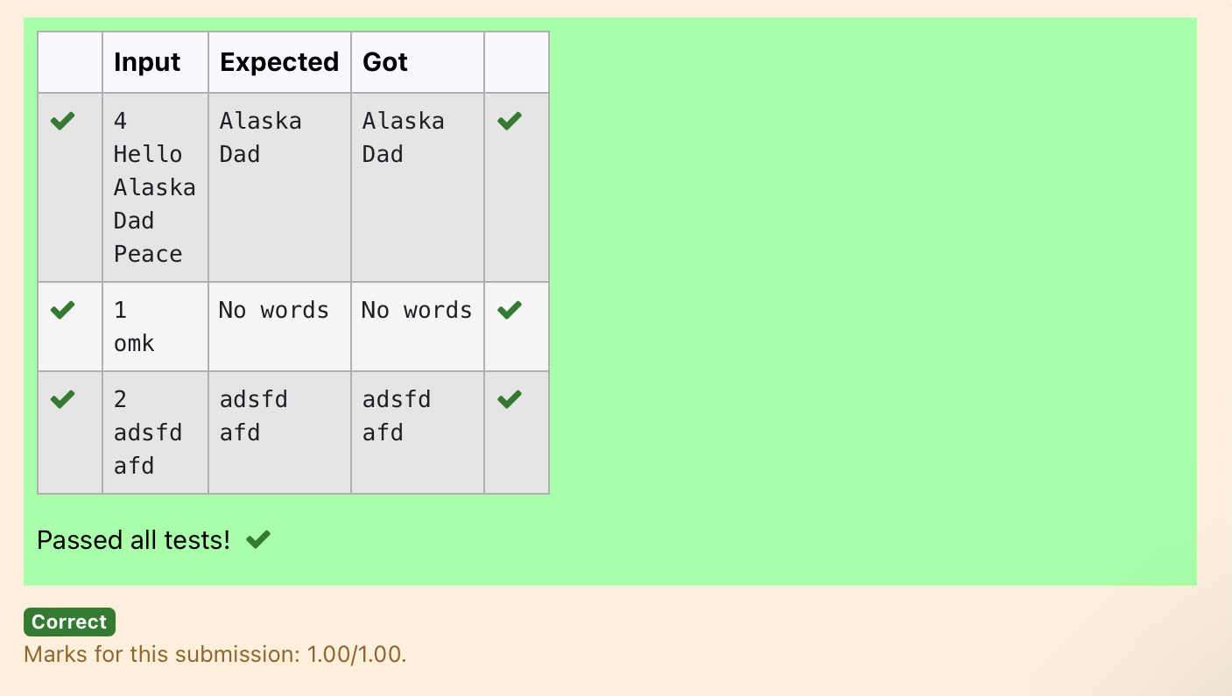

09 – Dictionary

Ex. No. : 9.1 Date: 15.06.2024
Register No.: 230401090 Name: MANOJ NJ

Uncommon words
A sentence is a string of single-space separated words where each word consists only of lowercase letters.A word is uncommon if it appears exactly once in one of the sentences, and does not appear in the other sentence.
Given two sentences s1 and s2, return a list of all the uncommon words. You may return the answer in any order.
Example 1:
Input: s1 = "this apple is sweet", s2 = "this apple is sour"
Output: ["sweet","sour"]
Example 2:

Input: s1 = "apple apple", s2 = "banana"
Output: ["banana"]
Constraints:
1 <= s1.length, s2.length <= 200
s1 and s2 consist of lowercase English letters and spaces.
s1 and s2 do not have leading or trailing spaces.
All the words in s1 and s2 are separated by a single space.
Note:
Use dictionary to solve the problem
For example:
Input | Result
this apple is sweet  this apple is sour | sweet sour

a=input().split()
b=input().split()
c1,c2,l={},{},[]
for i in a:
c1[i]=c1.get(i,0)+1
for j in b:
c2[j]=c2.get(j,0)+1
for w,c in c1.items():
if(c==1 and w not in b):
l.append(w)
for w,c in c2.items():
if(c==1 and w not in a):
l.append(w)
print(*l)

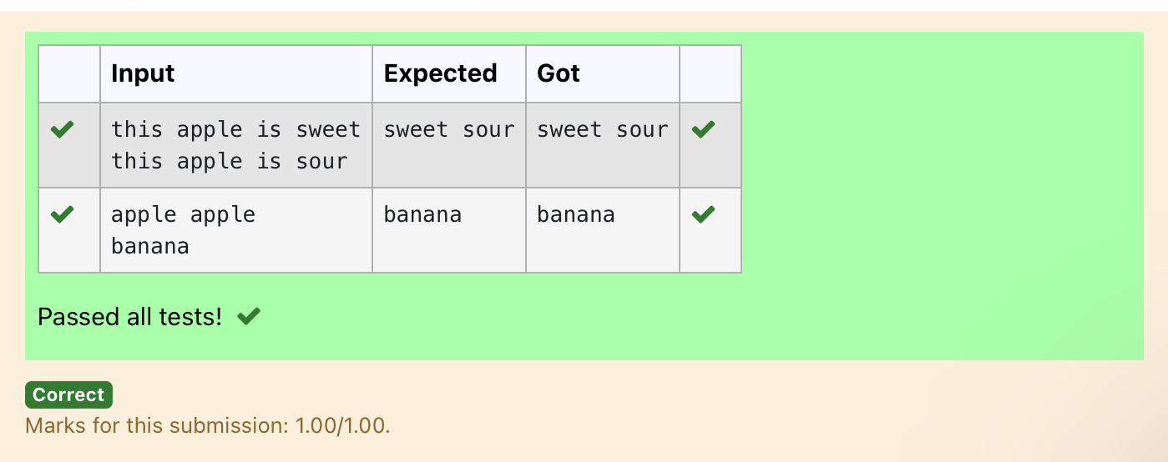

Ex. No. : 9.2 Date: 15.06.2024
Register No.: 230401090 Name : MANOJ NJ

Sort Dictionary by Values Summation
Give a dictionary with value lists, sort the keys by summation of values in value list.
Input : test_dict = {‘Gfg’ : [6, 7, 4], ‘best’ : [7, 6, 5]}
Output : {‘Gfg’: 17, ‘best’: 18}
Explanation : Sorted by sum, and replaced.
Input : test_dict = {‘Gfg’ : [8,8], ‘best’ : [5,5]}
Output : {‘best’: 10, ‘Gfg’: 16}
Explanation : Sorted by sum, and replaced.
Sample Input:
2
Gfg 6 7 4
Best 7 6 5
Sample Output
Gfg 17
Best 18

For example:
Input | Result
2  Gfg 6 7 4  Best 7 6 5 | Gfg 17  Best 18

a=int(input())
d={}
for i in range(a):
b=input()
b=b.partition(" ")
d[b[0]]=b[-1].split(" ")
n=list(d.values())
k=list(d.keys())
for i in range(len(n)):
s=0
for j in range(len(n[i])):
s+=int(n[i][j])
d.update({k[i]:s})
l=list(d.items())
if(l[0][1]<l[1][1]):
for k,v in d.items():
print(k,v)
else:
j=1
for k,v in d.items():
if(j==1):
k1,v1=k,v
j+=1
else:
print(k,v)
print(k1,v1)
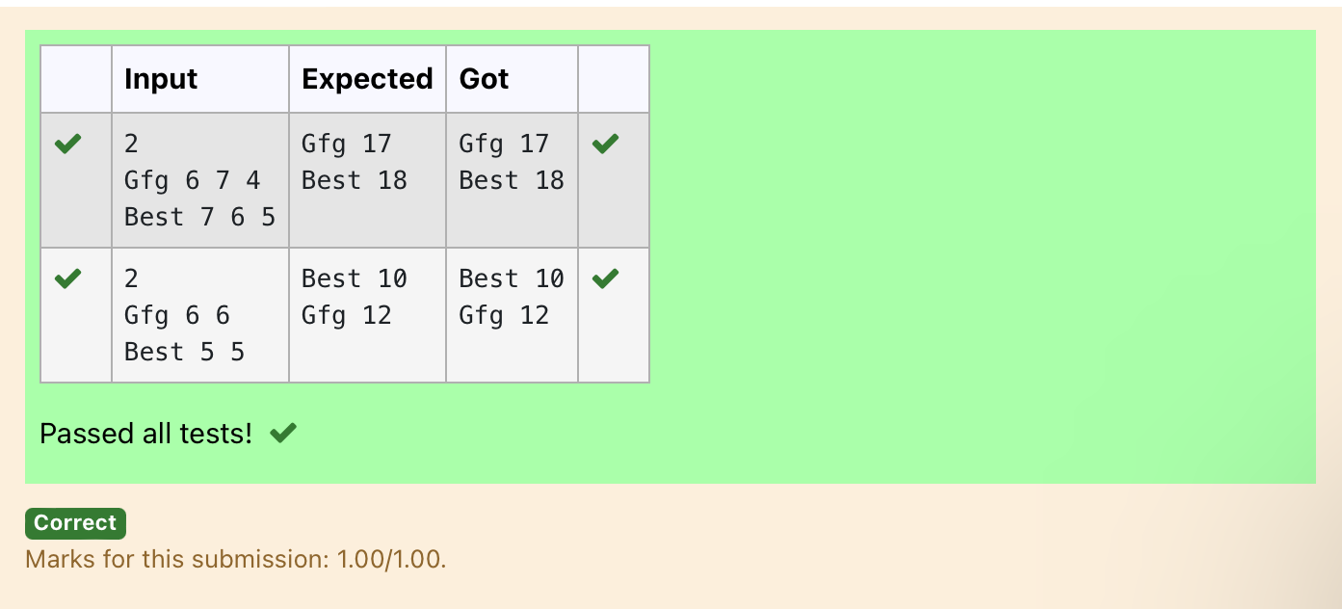

Ex. No. : 9.3 Date: 15.06.2024
Register No.: 230401090 Name: MANOJ NJ

Winner of Election
Given an array of names of candidates in an election. A candidate name in the array represents a vote cast to the candidate. Print the name of candidates received Max vote. If there is tie, print a lexicographically smaller name.
Examples:
Input : votes[] = {"john", "johnny", "jackie",
"johnny", "john", "jackie",
"jamie", "jamie", "john",
"johnny", "jamie", "johnny",
"john"};
Output : John
We have four Candidates with name as 'John', 'Johnny', 'jamie', 'jackie'. The candidates John and Johny get maximum votes. Since John is alphabetically smaller, we print it. Use dictionary to solve the above problem

Sample Input:
10
John
John
Johny
Jamie
Jamie
Johny
Jack
Johny
Johny
Jackie

Sample Output:
Johny

For example:
Input | Result
10  John  John  Johny  Jamie  Jamie  Johny  Jack  Johny  Johny  Jackie | Johny

n = int(input())

votes = {}

for _ in range(n):
candidate = input()
votes[candidate] = votes.get(candidate, 0) + 1

max_votes = max(votes.values())
max_candidates = [candidate for candidate, count in votes.items() if count == max_votes]

print(min(max_candidates))

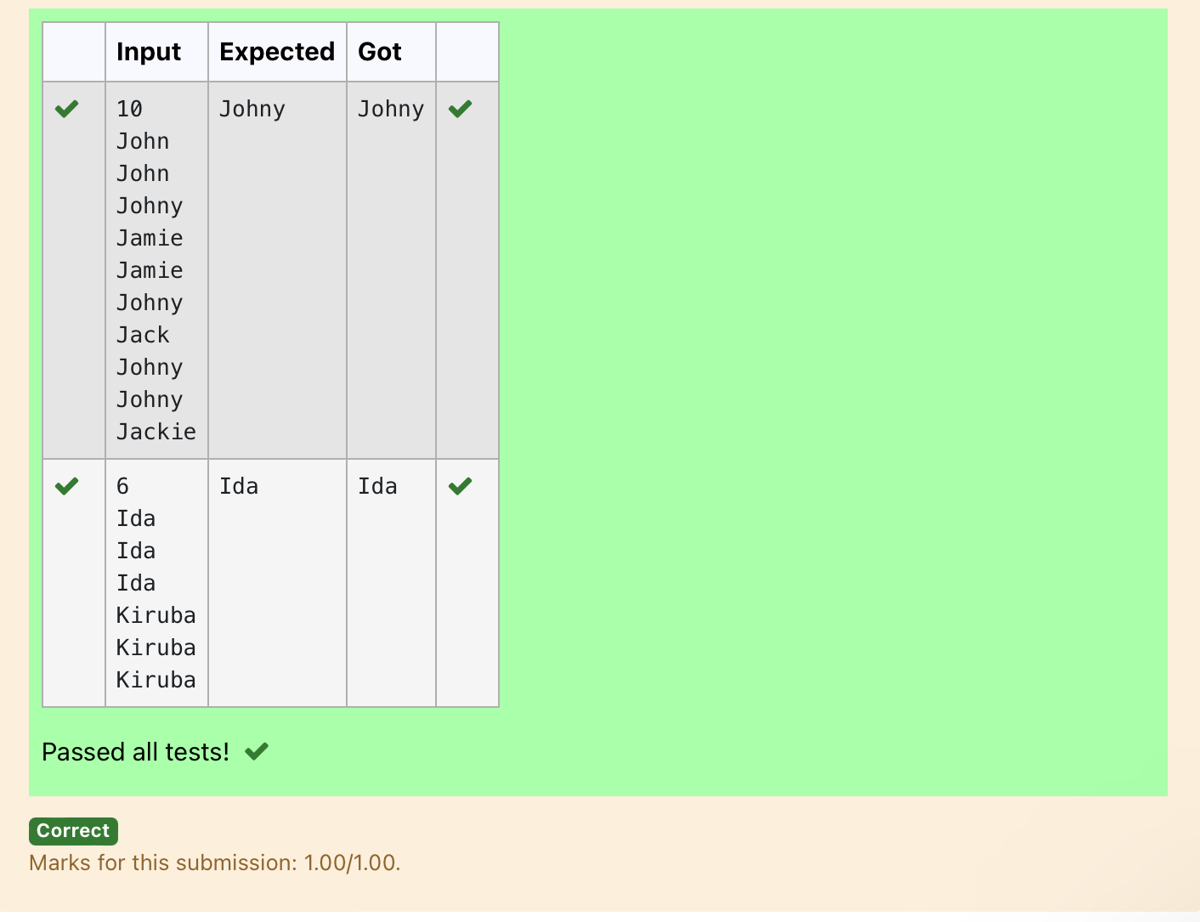

Ex. No. : 9.4 Date: 15.06.2024
Register No.: 230401090 Name: MANOJ NJ

Student Record

Create a student dictionary for n students with the student name as key and their test mark assignment mark and lab mark as values. Do the following computations and display the result.
1.Identify the student with the highest average score
2.Identify the student who as the highest Assignment marks
3.Identify the student with the Lowest lab marks
4.Identify the student with the lowest average score
Note:
If more than one student has the same score display all the student names

Sample input:
4
James 67 89 56
Lalith 89 45 45
Ram 89 89 89
Sita 70 70 70
Sample Output:
Ram
James Ram
Lalith
Lalith

n = int(input())
max_average = float('-inf')
min_average = float('inf')
max_assignment = float('-inf')
min_lab = float('inf')
max_average_students = []
max_assignment_students = []
min_lab_students = []
min_average_students = []
for _ in range(n):
name, test, assignment, lab = input().split()
test = int(test)
assignment = int(assignment)
lab = int(lab)
average = (test + assignment + lab) / 3
if average > max_average:
max_average = average
max_average_students = [name]
elif average == max_average:
max_average_students.append(name)
if average < min_average:
min_average = average
min_average_students = [name]
elif average == min_average:
min_average_students.append(name)
if assignment > max_assignment:
max_assignment = assignment
max_assignment_students = [name]
elif assignment == max_assignment:
max_assignment_students.append(name)
if lab < min_lab:
min_lab = lab
min_lab_students = [name]
elif lab == min_lab:
min_lab_students.append(name)
print(*sorted(max_average_students))
print(*sorted(max_assignment_students))
print(*sorted(min_lab_students))
print(*sorted(min_average_students))

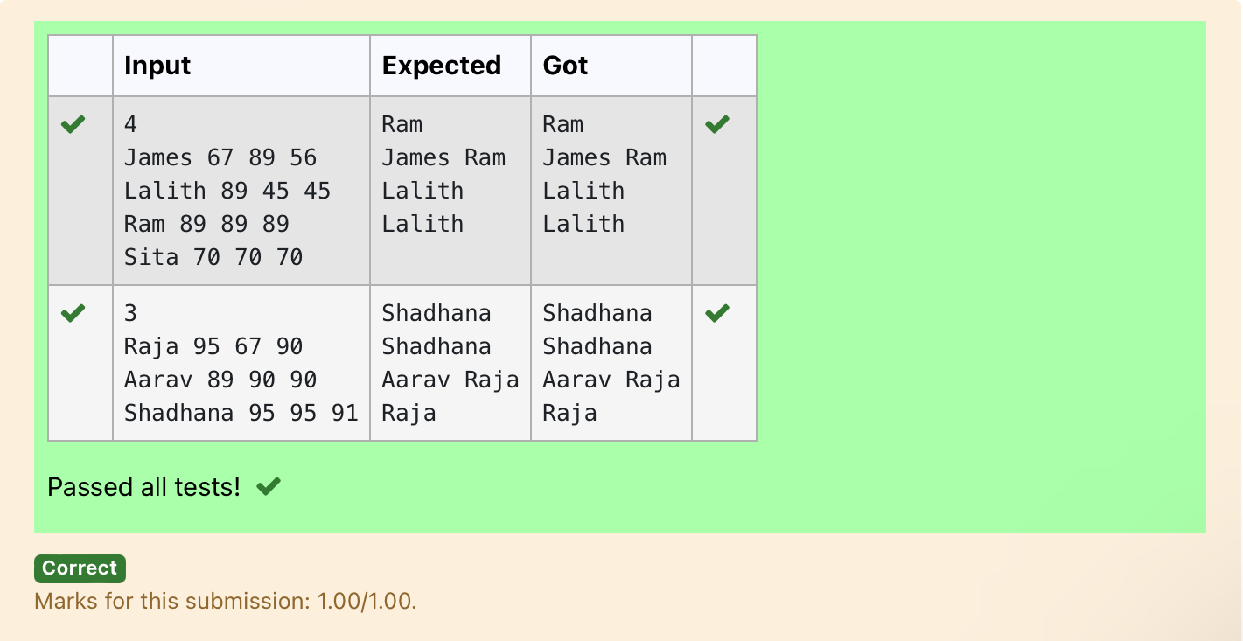

Ex. No. : 9.5 Date: 15.06.2024
Register No.: 230401090 Name: MANOJ NJ

Scramble Score

In the game of Scrabble™, each letter has points associated with it. The total score of a word is the sum of the scores of its letters. More common letters are worth fewer points while less common letters are worth more points.
Write a program that computes and displays the Scrabble™ score for a word. Create a dictionary that maps from letters to point values. Then use the dictionary to compute the score.
A Scrabble™ board includes some squares that multiply the value of a letter or the value of an entire word. We will ignore these squares in this exercise.

The points associated with each letter are shown below:
Points Letters
1 A, E, I, L, N, O, R, S, T and U
2 D and G
3 B, C, M and P
4 F, H, V, W and Y
5 K
8 J and X
10 Q and Z

Sample Input
REC
Sample Output
REC is worth 5 points.

letter_scores = {
'A': 1, 'E': 1, 'I': 1, 'L': 1, 'N': 1, 'O': 1, 'R': 1, 'S': 1, 'T': 1, 'U': 1,
'D': 2, 'G': 2,
'B': 3, 'C': 3, 'M': 3, 'P': 3,
'F': 4, 'H': 4, 'V': 4, 'W': 4, 'Y': 4,
'K': 5,
'J': 8, 'X': 8,
'Q': 10, 'Z': 10
}
word = input().upper()
score = sum(letter_scores.get(letter, 0) for letter in word)
print(word,"is worth",score,"points.")

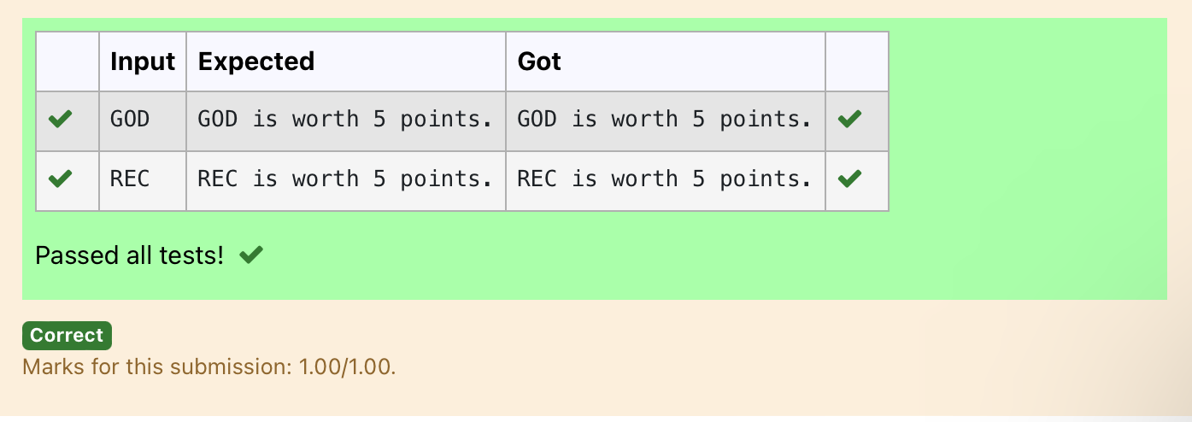

10 - Searching & Sorting

Ex. No. : 10.1 Date: 16.6.2024
Register No.: 230401090 Name: MANOJ NJ

Merge Sort
Write a Python program to sort a list of elements using the merge sort algorithm.

For example:
Input | Result
5  6 5 4 3 8 | 3 4 5 6 8

a=int(input())
l=[]
l.extend(input().split())
for i in range(a-1):
for j in range(a-1):
if(int(l[j])>int(l[j+1])):
t=int(l[j])
l[j]=int(l[j+1])
l[j+1]=t
for i in range(a):
print(int(l[i]),end=" ")

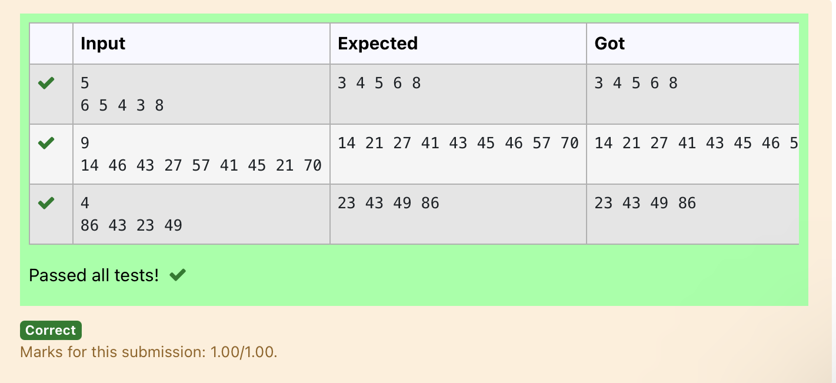

Ex. No. : 10.2 Date: 16.6.2024
Register No.: 230401090 Name: MANOJ NJ

Bubble Sort
Given an listof integers, sort the array in ascending order using the Bubble Sort algorithm above. Once sorted, print the following three lines:
1. List is sorted in numSwaps swaps., where numSwaps is the number of swaps that took place.
2. First Element: firstElement, the first element in the sorted list.
3. Last Element: lastElement, the last element in the sorted list.
For example, given a worst-case but small array to sort: a=[6,4,1]. It took 3 swaps to sort the array. Output would be
Array is sorted in 3 swaps.
First Element: 1
Last Element: 6

Input Format
The first line contains an integer,n , the size of the list a .
The second line contains n, space-separated integers a[i].
Constraints
· 2<=n<=600
· 1<=a[i]<=2x10⁶.
Output Format
You must print the following three lines of output:
1. List is sorted in numSwaps swaps., where numSwaps is the number of swaps that took place.
2. First Element: firstElement, the first element in the sorted list.
3. Last Element: lastElement, the last element in the sorted list.

Sample Input 0
3
1 2 3
Sample Output 0
List is sorted in 0 swaps.
First Element: 1
Last Element: 3

For example:
Input | Result
3  3 2 1 | List is sorted in 3 swaps.  First Element: 1  Last Element: 3
5  1 9 2 8 4 | List is sorted in 4 swaps.  First Element: 1  Last Element: 9

def bubble_sort(arr):
n = len(arr)
swaps = 0

for i in range(n):
for j in range(0, n-i-1):
if arr[j] > arr[j + 1]:
# Swap elements
arr[j], arr[j + 1] = arr[j + 1], arr[j]
swaps += 1

return swaps

# Input the size of the list
n = int(input())

# Input the list of integers
arr = list(map(int, input().split()))

# Perform bubble sort and count the number of swaps
num_swaps = bubble_sort(arr)

# Print the number of swaps
print("List is sorted in", num_swaps, "swaps.")

# Print the first element
print("First Element:", arr[0])

# Print the last element
print("Last Element:", arr[-1])

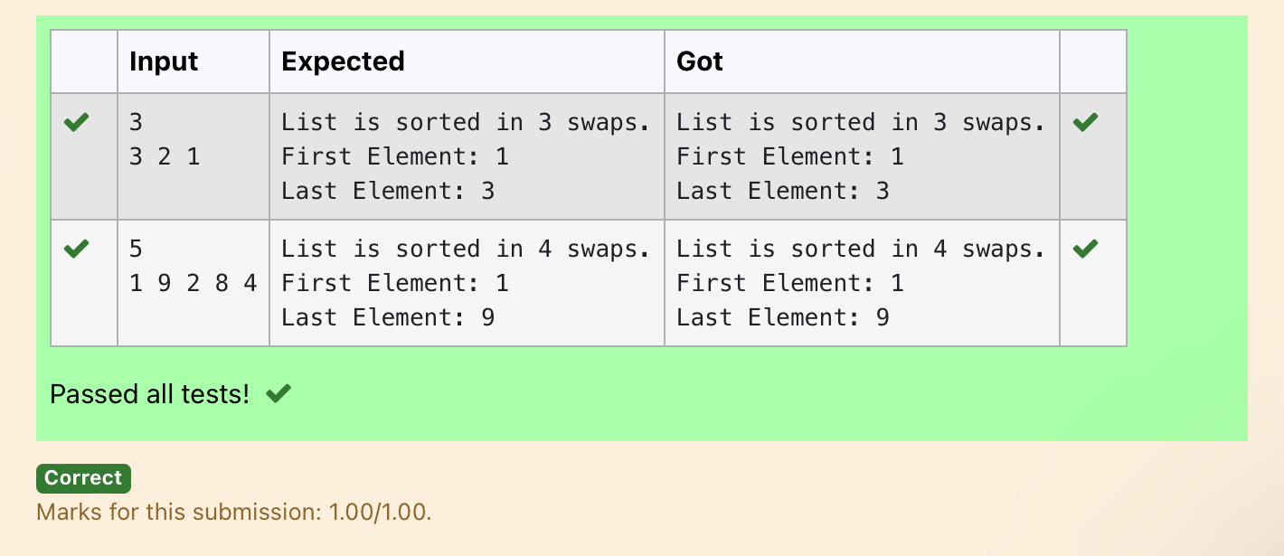

Ex. No. : 10.3 Date: 16.6.2024
Register No.: 230401090 Name: MANOJ NJ

Peak Element
Given an list, find peak element in it. A peak element is an element that is greater than its neighbors.
An element a[i] is a peak element if
A[i-1] <= A[i] >=a[i+1] for middle elements. [0<i<n-1]
A[i-1] <= A[i] for last element [i=n-1]
A[i]>=A[i+1] for first element [i=0]
Input Format
The first line contains a single integer n , the length of A .
The second line contains n space-separated integers,A[i].

Output Format
Print peak numbers separated by space.

Sample Input
5
8 9 10 2 6
Sample Output
10 6

For example:
Input | Result
4  12 3 6 8 | 12 8

def find_peak(arr):
peak_elements = []

# Check for the first element
if arr[0] >= arr[1]:
peak_elements.append(arr[0])

# Check for middle elements
for i in range(1, len(arr) - 1):
if arr[i - 1] <= arr[i] >= arr[i + 1]:
peak_elements.append(arr[i])

# Check for the last element
if arr[-1] >= arr[-2]:
peak_elements.append(arr[-1])

return peak_elements

# Input the length of the list
n = int(input())

# Input the list of integers
arr = list(map(int, input().split()))

# Find peak elements and print the result
peak_elements = find_peak(arr)
print(*peak_elements)

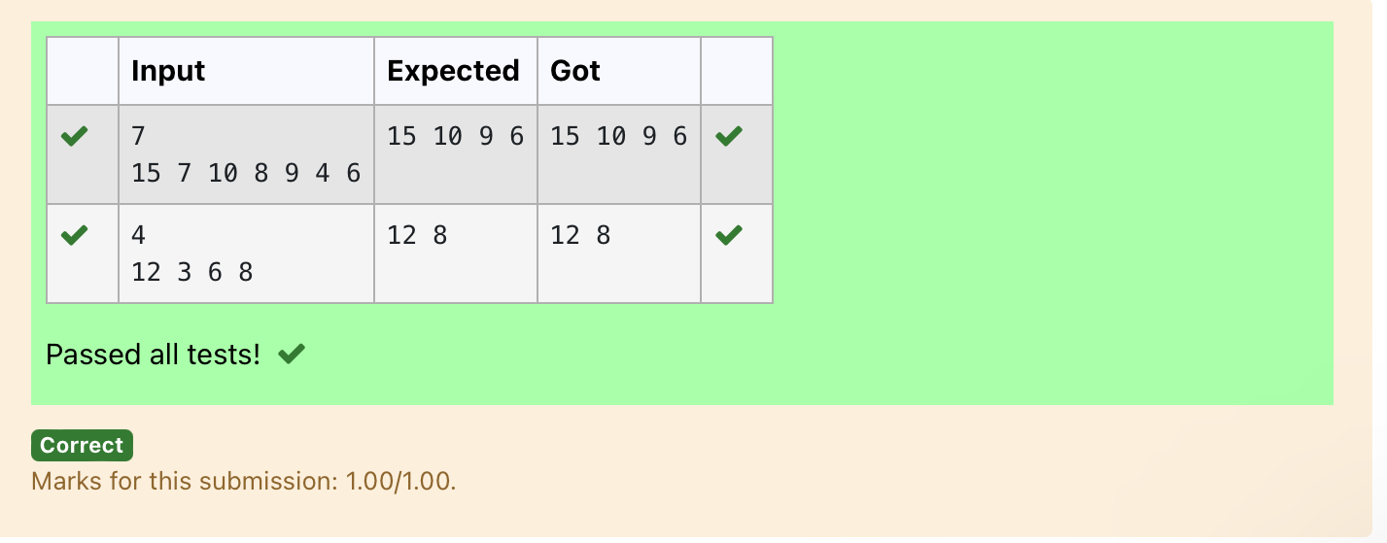

Ex. No. : 10.4 Date: 16.6.2024
Register No.: 230401090 Name: MANOJ NJ

Binary Search
Write a Python program for binary search.

For example:
Input | Result
1 2 3 5 8  6 | False
3 5 9 45 42  42 | True

a = input().split(",")
b = input()
print(b in a)

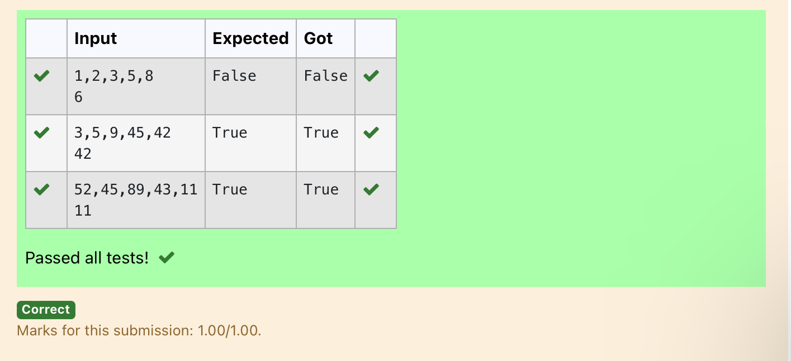

Ex. No. : 10.5 Date: 16.6.2024
Register No.: 2230401090 Name: MANOJ NJ

Frequency of Elements
To find the frequency of numbers in a list and display in sorted order.
Constraints:
1<=n, arr[i]<=100
Input:
1 68 79 4 90 68 1 4 5
output:
1 2
4 2
5 1
68 2
79 1
90 1

For example:
Input | Result
4 3 5 3 4 5 | 3 2  4 2  5 2

def count_frequency(arr):
frequency = {}

# Count the frequency of each number in the list
for num in arr:
frequency[num] = frequency.get(num, 0) + 1

# Sort the dictionary based on keys
sorted_frequency = sorted(frequency.items())

# Print the frequency of each number
for num, freq in sorted_frequency:
print(num, freq)

# Input the list of numbers
arr = list(map(int, input().split()))

# Count the frequency and print the result
count_frequency(arr)

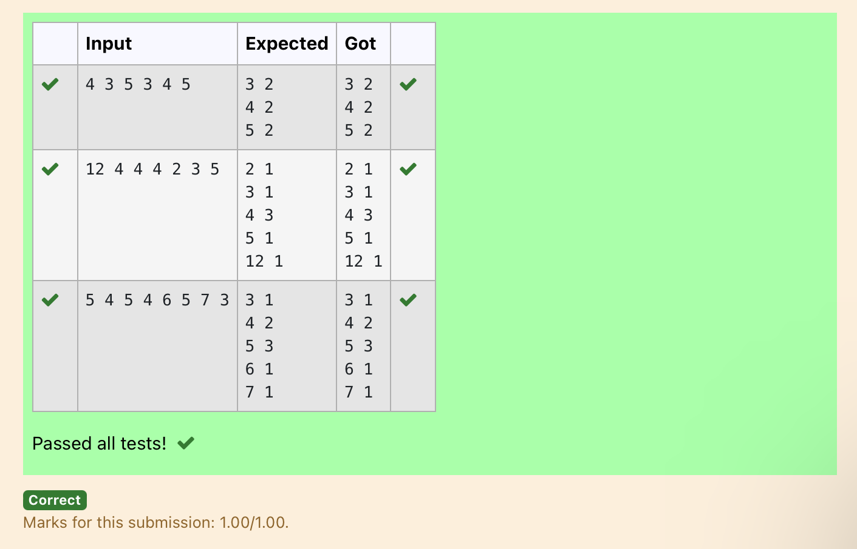

WEEK 11:
Ex. No. : 11.1 Date: 6.6.2024
Register No.: 2230401090 Name: MANOJ NJ

1.
Write a Python program that asks the user for their age and prints a message based on the age. Ensure that the program handles cases where the input is not a valid integer.
Input Format: A single line input representing the user's age.
Output Format: Print a message based on the age or an error if the input is invalid.

For example:
Input | Result
twenty | Error: Please enter a valid age.
25 | You are 25 years old.
-1 | Error: Please enter a valid age.

try:
a=input()
if(len(a)==0):
print("Error: Please enter a valid age.")
elif a.isnumeric():
print("You are",a,"years old.")
else:
print("Error: Please enter a valid age.")
except:
print("Error: Please enter a valid age.")
OUTOUT:
 | Input | Expected | Got
 | twenty | Error: Please enter a valid age. | Error: Please enter a valid age.
 | 25 | You are 25 years old. | You are 25 years old.
 | -1 | Error: Please enter a valid age. | Error: Please enter a valid age.
 | 150 | You are 150 years old. | You are 150 years old.
 |  | Error: Please enter a valid age. | Error: Please enter a valid age.
Passed all tests!
Correct
2.
Ex. No. : 11.2 Date: 6.6.2024
Register No.: 2230401090 Name: MANOJ NJ

Problem Description:
Write a Python program that asks the user for their age and prints a message based on the age. Ensure that the program handles cases where the input is not a valid integer.

Input Format:
A single line input representing the user's age.

Output Format:
Print a message based on the age or an error if the input is invalid.
For example:
Input | Result
25 | You are 25 years old.
rec | Error: Please enter a valid age.
-5 | Error: Please enter a valid age.

try:
a=input()
if(len(a)==0):
print("Error: Please enter a valid age.")
elif a.isnumeric():
print("You are",a,"years old.")
else:
print("Error: Please enter a valid age.")
except:
print("Error: Please enter a valid age.")
OUTPUT:
 | Input | Expected | Got
 | 25 | You are 25 years old. | You are 25 years old.
 | rec | Error: Please enter a valid age. | Error: Please enter a valid age.
 | !@# | Error: Please enter a valid age. | Error: Please enter a valid age.
Passed all tests!
Correct
3.
Ex. No. : 11.3 Date: 6.6.2024
Register No.: 2230401090 Name: MANOJ NJ

Problem Description:
Write a Python script that asks the user to enter a number within a specified range (e.g., 1 to 100). Handle exceptions for invalid inputs and out-of-range numbers.
Input Format:
User inputs a number.
Output Format:
Confirm the input or print an error message if it's invalid or out of range.
For example:
Input | Result
1 | Valid input.
101 | Error: Number out of allowed range
rec | Error: invalid literal for int()

def main():
min_range = 1
max_range = 100

try:
num = int(input())
if num < min_range or num > max_range:
print("Error: Number out of allowed range")
else:
print("Valid input.")
except ValueError:
print("Error: invalid literal for int()")

if __name__ == "__main__":

OUTPUT:
 | Input | Expected | Got
 | 1 | Valid input. | Valid input.
 | 100 | Valid input. | Valid input.
 | 101 | Error: Number out of allowed range | Error: Number out of allowed range
Passed all tests!
Correct
Marks for this submission: 1.00/1.00.

4.

Ex. No. : 11.4 Date: 6.6.2024
Register No.: 2230401090 Name: MANOJ NJ

Develop a Python program that safely performs division between two numbers provided by the user. Handle exceptions like division by zero and non-numeric inputs.
Input Format: Two lines of input, each containing a number.
Output Format: Print the result of the division or an error message if an exception occurs.

For example:
Input | Result
10  2 | 5.0
10  0 | Error: Cannot divide or modulo by zero.
ten  5 | Error: Non-numeric input provided.
def main():
try:
num1 = float(input())
num2 = float(input())

division_result = num1 / num2
modulo_result = num1 % num2

print(division_result)

except ValueError:
print("Error: Non-numeric input provided.")
except ZeroDivisionError:
print("Error: Cannot divide or modulo by zero.")

if __name__ == "__main__":
main()

OUTPUT:
 | Input | Expected | Got
 | 10  2 | 5.0 | 5.0
 | 10  0 | Error: Cannot divide or modulo by zero. | Error: Cannot divide or modulo by zero.
 | ten  5 | Error: Non-numeric input provided. | Error: Non-numeric input provided.
Passed all tests!
Correct

5.
Ex. No. : 11.5 Date: 6.6.2024
Register No.: 2230401090 Name: MANOJ NJ

Problem Description:
Develop a Python program that safely calculates the square root of a number provided by the user. Handle exceptions for negative inputs and non-numeric inputs.
Input Format:
User inputs a number.
Output Format:
Print the square root of the number or an error message if an exception occurs.
For example:
Input | Result
16 | The square root of 16.0 is 4.00
-4 | Error: Cannot calculate the square root of a negative number.
rec | Error: could not convert string to float
try:
a=float(input())
if(a<0):
print("Error: Cannot calculate the square root of a negative number.")
else:
print("The square root of",a,"is {:.2f}".format(a**0.5))
except:
print("Error: could not convert string to float")

OUTPUT:
 | Input | Expected | Got
 | 16 | The square root of 16.0 is 4.00 | The square root of 16.0 is 4.00
 | 0 | The square root of 0.0 is 0.00 | The square root of 0.0 is 0.00
 | -4 | Error: Cannot calculate the square root of a negative number. | Error: Cannot calculate the square root of a negative number.
Passed all tests!
Correct

WEEK 12:

1.
Ex. No. : 12.1 Date: 7.6.2024
Register No.: 2230401090 Name: MANOJ NJ

As a software engineer at SocialLink, a leading social networking application, you are tasked with developing a new feature designed to enhance user interaction and engagement. The company aims to introduce a system where users can form connections based on shared interests and activities. One of the feature's components involves analyzing pairs of users based on the activities they've participated in, specifically looking at the numerical difference in the number of activities each user has participated in.
Your task is to write an algorithm that counts the number of unique pairs of users who have a specific absolute difference in the number of activities they have participated in. This algorithm will serve as the backbone for a larger feature that recommends user connections based on shared participation patterns.
Problem Statement
Given an array activities representing the number of activities each user has participated in and an integer k, your job is to return the number of unique pairs (i, j) where activities[i] - activities[j] = k, and i < j. The absolute difference between the activities should be exactly k.
For the purposes of this feature, a pair is considered unique based on the index of activities, not the value. That is, if there are two users with the same number of activities, they are considered distinct entities.
Input Format
The first line contains an integer, n, the size of the array nums.
The second line contains n space-separated integers, nums[i].
The third line contains an integer, k.

Output Format
Return a single integer representing the number of unique pairs (i, j)
where | nums[i] - nums[j] | = k and i < j.

Constraints:
1 ≤ n ≤ 10⁵
-10⁴ ≤ nums[i] ≤ 10⁴
0 ≤ k ≤ 10⁴

For example:
Input | Result
5  1 3 1 5 4  0 | 1
4  1 2 2 1  1 | 4
def count_pairs_with_difference_k(activities, k):
count = 0
n = len(activities)
for i in range(n):
for j in range(i + 1, n):
if abs(activities[i] - activities[j]) == k:
count += 1
return count

# Reading input
n = int(input())
activities = list(map(int, input().split()))
k = int(input())

# Calling function and printing the result
print(count_pairs_)

OUTPUT:

 | Input | Expected | Got
 | 4  1 2 3 4  1 | 3 | 3
 | 5  1 3 1 5 4  0 | 1 | 1
 | 4  1 2 2 1  1 | 4 | 4
Passed all tests!
Correct

2.
Ex. No. : 12.2 Date: 7.6.2024
Register No.: 2230401090 Name: MANOJ NJ

Given an integer n, print true if it is a power of four. Otherwise, print false.
An integer n is a power of four, if there exists an integer x such that n == 4^{x}.
For example:
Input | Result
16 | True
5 | False
def is_power_of_four(n):
if n <= 0:
return False
while n > 1:
if n % 4 != 0:
return False
n //= 4
return True

# Test the function
n = int(input())
print(is_power_of_four(n))

OUTPUT:
 | Input | Expected | Got
 | 16 | True | True
 | 5 | False | False
 | 1 | True | True
 | -1 | False | False
Passed all tests!
Correct

3.
Ex. No. : 12.3 Date: 7.6.2024
Register No.: 2230401090 Name: MANOJ NJ

3. Background:
Dr. John Wesley maintains a spreadsheet with student records for academic evaluation. The spreadsheet contains various data fields including student IDs, marks, class names, and student names. The goal is to develop a system that can calculate the average marks of all students listed in the spreadsheet.

Problem Statement:
Create a Python-based solution that can parse input data representing a list of students with their respective marks and other details, and compute the average marks. The input may present these details in any order, so the solution must be adaptable to this variability.

Input Format:

The first line contains an integer N, the total number of students.
The second line lists column names in any order (ID, NAME, MARKS, CLASS).
The next N lines provide student data corresponding to the column headers.
Output Format:

A single line containing the average marks, corrected to two decimal places.
Constraints:

1≤N≤100
Column headers will always be in uppercase and will include ID, MARKS, CLASS, and NAME.
Marks will be non-negative integers.

For example:
Input | Result
3  ID NAME MARKS CLASS  101 John 78 Science  102 Doe 85 Math  103 Smith 90 History | 84.33
3  MARKS CLASS NAME ID  78 Science John 101  85 Math Doe 102  90 History Smith 103 | 84.33
def calculate_average_marks(data):
total_marks = 0
num_students = 0

for student in data:
if 'MARKS' in student:
total_marks += int(student['MARKS'])
num_students += 1

if num_students == 0:
return 0

return total_marks / num_students

# Read input
N = int(input())
columns = input().split()

# Initialize data structure to store student records
students = []

# Read student data
for _ in range(N):
student_data = input().split()
student_record = {columns[i]: student_data[i] for i in range(len(columns))}
students.append(student_record)

# Calculate average marks
average_marks = calculate_average_marks(students)

# Print average marks with two decimal places
print("{:.2f}".format(average_marks))

OUTPUT:
 | Input | Expected | Got
 | 3  ID NAME MARKS CLASS  101 John 78 Science  102 Doe 85 Math  103 Smith 90 History | 84.33 | 84.33
 | 3  MARKS CLASS NAME ID  78 Science John 101  85 Math Doe 102  90 History Smith 103 | 84.33 | 84.33
Passed all tests!
Correct
Marks for this submission: 1.00/1.00.

4.
Ex. No. : 12.4 Date: 7.6.2024
Register No.: 2230401090 Name: MANOJ NJ

Background:
Raghu owns a shoe shop with a varying inventory of shoe sizes. The shop caters to multiple customers who have specific size requirements and are willing to pay a designated amount for their desired shoe size. Raghu needs an efficient system to manage his inventory and calculate the total revenue generated from sales based on customer demands.

Problem Statement:
Develop a Python program that manages shoe inventory and processes sales transactions to determine the total revenue generated. The program should handle inputs of shoe sizes available in the shop, track the number of each size, and match these with customer purchase requests. Each transaction should only proceed if the desired shoe size is in stock, and the inventory should update accordingly after each sale.

Input Format:
First Line: An integer X representing the total number of shoes in the shop.
Second Line: A space-separated list of integers representing the shoe sizes in the shop.
Third Line: An integer N representing the number of customer requests.
Next N Lines: Each line contains a pair of space-separated values:
The first value is an integer representing the shoe size a customer desires.
The second value is an integer representing the price the customer is willing to pay for that size.

Output Format:
Single Line: An integer representing the total amount of money earned by Raghu after processing all customer requests.

Constraints:
1≤X≤1000 — Raghu's shop can hold between 1 and 1000 shoes.
Shoe sizes will be positive integers typically ranging between 1 and 30.
1≤N≤1000 — There can be up to 1000 customer requests in a single batch.
The price offered by customers will be a positive integer, typically ranging from $5 to $100 per shoe.

For example:
Input | Result
10  2 3 4 5 6 8 7 6 5 18  6  6 55  6 45  6 55  4 40  18 60  10 50 | 200
5  5 5 5 5 5  5  5 10  5 10  5 10  5 10  5 10 | 50
Answer:(penalty regime: 0 %)
class ShoeInventory:
def __init__(self, shoe_sizes):
self.inventory = {size: 0 for size in shoe_sizes}

def add_shoes(self, size, quantity):
self.inventory[size] += quantity

def sell_shoes(self, size):
if self.inventory.get(size, 0) > 0:
self.inventory[size] -= 1
return True
return False

class TransactionManager:
def __init__(self, shoe_inventory):
self.shoe_inventory = shoe_inventory
self.total_revenue = 0

def process_transactions(self, customer_requests):
for size, price in customer_requests:
if self.shoe_inventory.sell_shoes(size):
self.total_revenue += price

# Read input
X = int(input()) # Total number of shoes
shoe_sizes = list(map(int, input().split())) # Shoe sizes available
N = int(input()) # Number of customer requests

# Initialize shoe inventory
inventory = ShoeInventory(shoe_sizes)

# Populate initial inventory
for size in shoe_sizes:
inventory.add_shoes(size, X // len(shoe_sizes))

# Initialize transaction manager
transaction_manager = TransactionManager(inventory)

# Process transactions
for _ in range(N):
size, price = map(int, input().split())
transaction_manager.process_transactions([(size, price)])

# Print total revenue
print(transaction_manager.total_revenue)

OUTPUT:
 | Input | Expected | Got
 | 10  2 3 4 5 6 8 7 6 5 18  6  6 55  6 45  6 55  4 40  18 60  10 50 | 200 | 200
 | 5  5 5 5 5 5  5  5 10  5 10  5 10  5 10  5 10 | 50 | 50
 | 4  4 4 6 6  5  4 25  4 25  6 30  6 55  6 55 | 135 | 135
Passed all tests!
Correct
Marks for this submission: 1.00/1.00.

5.
Ex. No. : 12.5 Date: 7.6.2024
Register No.: 2230401090 Name: MANOJ NJ

Background:
Rose manages a personal library with a diverse collection of books. To streamline her library management, she needs a program that can categorize books based on their genres, making it easier to find and organize her collection.

Problem Statement:
Develop a Python program that reads a series of book titles and their corresponding genres from user input, categorizes the books by genre using a dictionary, and outputs the list of books under each genre in a formatted manner.

Input Format:

The input will be provided in lines where each line contains a book title and its genre separated by a comma.
Input terminates with a blank line.
Output Format:

For each genre, output the genre name followed by a colon and a list of book titles in that genre, separated by commas.
Constraints:

Book titles and genres are strings.
Book titles can vary in length but will not exceed 100 characters.
Genres will not exceed 50 characters.
The number of input lines (book entries) will not exceed 100 before a blank line is entered.
For example:
Input | Result
Introduction to Programming, Programming  Advanced Calculus, Mathematics | Programming: Introduction to Programming  Mathematics: Advanced Calculus
Fictional Reality, Fiction  Another World, Fiction | Fiction: Fictional Reality, Another World
def categorize_books_sorted():
books = {}

while True:
try:
user_input = input().strip()
except EOFError:
break

if not user_input:
break

title, genre = user_input.split(',')
genre = genre.strip()

if genre in books:
books[genre].append(title)
else:
books[genre] = [title]

for genre in sorted(books.keys()):
print(f"{genre}: {', '.join(books[genre])}")

categorize_books_sorted()

OUTPUT:
 | Input | Expected | Got
 | Introduction to Programming, Programming  Advanced Calculus, Mathematics | Programming: Introduction to Programming  Mathematics: Advanced Calculus | Programming: Introduction to Programming  Mathematics: Advanced Calculus
 | Fictional Reality, Fiction  Another World, Fiction | Fiction: Fictional Reality, Another World | Fiction: Fictional Reality, Another World
Passed all tests!
Correct

